Stockholm Convention on Persistent Organic Pollutants
POPs Review Committee (POPRC)

ENDOSULFAN

DRAFT RISK PROFILE
(Detailed version)

Draft prepared by the ad hoc working group on Endosulfan
under the POPs Review Committee
of the Stockholm Convention

April 2009

Draft Risk Profile (Detailed version) for Endosulfan

Note:
In accordance with the procedure laid down in Article 8 of the Stockholm Convention, this draft was prepared by the ad hoc working group on endosulfan under the Persistent Organic Pollutants Review Committee (POPRC) during its intersessional period between the fourth and the fifth meetings. For more details, please refer to the report of the meeting available at the Convention’s web site: http://www.pops.int/poprc/.
Parties and observers to the Stockholm Convention are invited to review the draft and provide technical and substantive comments to the Secretariat. Comments received will be considered by the ad hoc working group and the revised draft will be considered by the Committee at the fifth meeting scheduled from 12 to 16 October 2009 in Geneva. Please submit your comments to the Secretariat of the Stockholm Convention preferably by e-mail no later than 2 June, 2009 to:

Secretariat of the Stockholm Convention
Att: POPs Review Committee
United Nations Environment Programme
11-13 chemin des Anémones
CH-1219, Chatelaine, Geneva, Switzerland
Fax: (+41 22) 917 8098
E-mail: ssc@pops.int

If you need further information, please contact the Secretariat, Ms. Kei Ohno (e-mail: kisobe@pops.int; telephone +41 22 917 8201).

Table of Contents

1. Introduction 4
1.1 Chemical identity 7
1.2 Physical-chemical properties 7
2. Summary information relevant to the risk profile 9
2.1 Sources 9
2.1.1 Production, trade, stockpiles 9
2.1.2 Uses 11
2.2 Environmental fate 16
2.2.1 Persistence 16
2.2.2 Potential for bioaccumulation 18
2.2.3 Long range rransport 27
2.3 Releases and exposure estimations 31
2.3.1 Environmental monitoring data 32
2.4. Hazard assessment 41
2.4.1 Adverse effects on aquatic organisms 41
2.4.2 Adverse effects on terrestrial organisms 42
2.4.3 Adverse effects on human health 42
3. Synthesis of the information 48
4. Conclusions 52
5. References 53

1. Introduction
Endosulfan, a synthetic organochlorine compound, is widely used as an agricultural insecticide. It was introduced into the market already back in the mid 1950s but plant production products containing endosulfan are still used in a number of countries worldwide.
The European Community and its member States that are Parties to the Convention submitted a proposal to list endosulfan in Annexes A, B or C of the Convention in 2007 (UNEP/POPS/POPRC.3/5).
At its third meeting, the Committee agreed to defer consideration of the proposal to its fourth meeting pending receipt of additional information. The information was received and the following decision was adopted at the four meeting of the POPRC:
POPRC-4/5: Endosulfan
The Persistent Organic Pollutants Review Committee,
Having examined the proposal by the European Community and its member States that are Parties to the Stockholm Convention on Persistent Organic Pollutants to list endosulfan, including: alpha (α) endosulfan (Chemical Abstracts Service number 959-98-8) beta (β) endosulfan (Chemical Abstracts Service number 33213-65-9), technical endosulfan (Chemical Abstracts Service number 115-29-7), in Annexes A, B and/or C to the Convention and having applied the screening criteria specified in Annex D to the Convention,
1. Decides, in accordance with paragraph 4 (a) of Article 8 of the Convention, that it is satisfied that the screening criteria have been fulfilled for endosulfan, as set out in the evaluation contained in the annex to the present decision;
2. Decides also, in accordance with paragraph 6 of Article 8 of the Convention and paragraph 29 of decision SC-1/7 of the Conference of the Parties to the Stockholm Convention, to establish an ad hoc working group to review the proposal further and to prepare a draft risk profile in accordance with Annex E to the Convention;
3. Invites, in accordance with paragraph 4 (a) of Article 8 of the Convention, Parties and observers to submit to the Secretariat the information specified in Annex E before 9 January 2009.
Annex to decision POPRC-4/5
Evaluation of endosulfan against the criteria of Annex D
A. Background
1. The primary source of information for the preparation of this evaluation was the proposal submitted by the European Community and its member States that are Parties to the Convention, contained in document UNEP/POPS/POPRC.4/14.
2. Given a comparable toxicity of the sulfate metabolite, a number of authors make use of the term “endosulfan (sum)” which includes the combined residues of both isomers of the parent and endosulfan sulfate. The information provided included data from alpha and beta endosulfan and the transformation product endosulfan sulfate.
B. Evaluation
4. The proposal was evaluated in the light of the requirements of Annex D, regarding the identification of the chemical (paragraph 1 (a)) and the screening criteria (paragraphs 1 (b)–(e)):
(a) Chemical identity:
(i) Adequate information was provided in the proposal and supporting documents;
(ii) The chemical structure was provided;
The chemical identity of endosulfan, alpha (α) endosulfan, beta (β) endosulfan, and technical endosulfan are clearly established;
(b) Persistence:
- Based on combined DT₅₀ measured in laboratory studies for alpha and beta endosulfan and endosulfan sulfate, the estimated combined half-life in soil for endosulfan (alpha, beta isomers and endosulfan sulfate) ranges between 28 and 391 days; the literature, however, reports both higher and lower values. These values are varied and some exceed the criterion of persistence. Taking into account the half-life of alpha and beta endosulfan, which is followed by the half-life of endosulfan sulfate, together these values exceed the criterion of six months’ persistence in soil. In water-sediment laboratory studies, the combined half-lives in the total system were between 18 and 21days, but mineralization was very low, <0.1%, indicating additional concern on endosulfan-related metabolisms. Under certain environmental conditions the screening criteria would not be met. Taking into account the combined degradation rate of the three major components, however, there is information to support the consideration of endosulfan as being persistent;
There is sufficient evidence that endosulfan meets the criterion on persistence;
(c) Bioaccumulation:
(i) Reported bioconcentration factors in aquatic species vary between 1,000 and 3,000 on whole-body-weight basis, which is below the criterion for the bioconcentration factor of 5,000. The largest values have been observed for fish. In addition, the log Kow is measured at 4.7 which is below the criterion of 5;
(ii) Bioaccumulation modelling studies published in the literature indicate that biomagnification of endosulfan by terrestrial (air-breathing) organisms is a concern, with predicted biomagnification factor (BMF) values ranging from 2.5 to 28 for herbivorous and carnivorous wildlife respectively. This modelling technique is new, however, and not yet widely recognized and requires further verification. Data indicate that the relative distribution of the different metabolites among taxonomic groups may differ considerably; combined estimations indicate a potential for bioaccumulation, which is particularly relevant because of the high toxicity and ecotoxicity of endosulfan isomers and several metabolites. The bioaccumulation of endosulfan has been observed for some animal taxa but in other cases there is no evidence. The environmental concern rests on the combination of this bioaccumulation potential with high toxicity and ecotoxicity;
(iii) Endosulfan was detected in adipose tissue and blood of animals in the Arctic and the Antarctic. Endosulfan has also been detected in the blubber of minke whales and in the liver of northern fulmars;
There is sufficient evidence that endosulfan meets the criterion on bioaccumulation.
(d) Potential for long-range environmental transport:
(i) Levels of 0.9 and 3.02 ng·g⁻¹ of endosulfan in the blubber of elephant seals in the Antarctic provide evidence of potential concern for endosulfan found in areas distant from its sources of release but the toxicological significance is not known. Other data, however, also show lower levels in other areas of the globe;
(ii) Evidence of long-range environmental transport of endosulfan and endosulfan sulfate is confirmed by Arctic monitoring data;
(iii) Volatilization is well documented. An atmospheric half-life of 27 d (± 11 days) was estimated. Half-lives of > 2.7 days for alpha endosulfan and of > 15 days for beta endosulfan were reported. Half-life values of less than two days have also been calculated. Arctic monitoring publications indicate the potential for long-range environmental transport of endosulfan residues. Overall persistence (Pov) for the endosulfan family is in the region of 10 days for tropical air and soil. The Arctic contamination potential after 10 years of continuous releases was between 0.1 and 1.0%;
There is sufficient evidence that endosulfan meets the criterion on potential for long-range environmental transport;
(e) Adverse effects:
(i) There are a number of papers reporting adverse effects of endosulfan in humans and other species;
(ii) There are toxicity and ecotoxicity data available for both endosulfan isomers and several metabolites. Endosulfan is a very toxic chemical for many kinds of animals. Metabolism occurs rapidly, but the oxidized metabolite endosulfan sulfate shows an acute toxicity similar to that of the parent compound. Endosulfan has the potential to cause endocrine disruption in both terrestrial and aquatic species. Endosulfan causes neurotoxicity, haematological effects and nephrotoxicity but shows no carcinogenic or mutagenic properties. Studies vary on the conclusion for teratogenic effects;
(ii) Degradation studies indicate that endosulfan is degraded into a large number of other metabolites, all of them retaining the endosulfan structure, and some of them showing significant toxicity while others do not;
There is sufficient evidence that endosulfan meets the criterion on adverse effects.
C. Conclusion
4. The Committee concluded that endosulfan met the screening criteria specified in Annex
In accordance with paragraph 4 (a) of Article 8 of the Convention, the Committee decided, at its fourth meeting held from 13 to 17 October 2008 in Geneva, to invite Parties and observers to submit the Annex E information on Endosulfan proposed by European Community and its member States that are Parties to the Convention for listing in Annexes A, B, and/or C of the Convention in order to prepare a draft risk profile. A large number of parties and observed have responded to this invitation. The submitted information is presented in this document.
In parallel, the European Community has contracted a review of the recently available scientific information on endosulfan. About three hundred relevant scientific papers, mostly published between 2006 and 2009, have been selected from the over thousand related scientific papers published on endosulfan. This information has also been incorporated in this detailed risk profile.

1.1 Chemical identity
Technical endosulfan is a mixture of two isomers. The proportion of each isomer in the mixture varies from 2:1 to 7:3 for the alpha- and the beta-isomers, respectively. The chemical identity is summarised in Table 1.
Table 1. Chemical identity of endosulfan (Source European Union dossier (INIA, 1999-2004)
Chemical name (IUPAC) | 6,7,8,9,10,10-hexachloro-1,5,5a,6,9,9a-hexahydro-6,9-methano-2,4,3-benzo-dioxathiepin-3-oxide
Chemical name (CA) | 6,9-methano-2,4,3-benzodioxathiepin,6,7,8,9,10,10-hexachloro-1,5,5a,6,9,9a-hexahydro-3-oxide
CIPAC No | 89
CAS No | 115-29-7
EEC No (EINECSor ELINCS) | 204-079-9
FAO Specification | CP/228
Minimum purity of the active substance as manufactured (g/kg) | 940 +/- 20 g / Kg (FAO)
Molecular formula | C₉H₆Cl₆O₃S
Molecular mass | 406.96 g/mol
Generic structural formula | 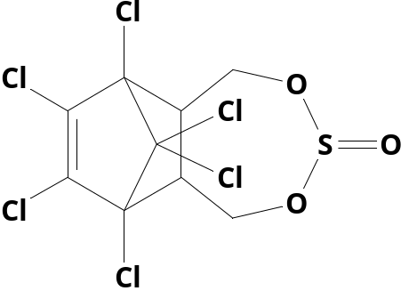

Structural formulas of the isomers | 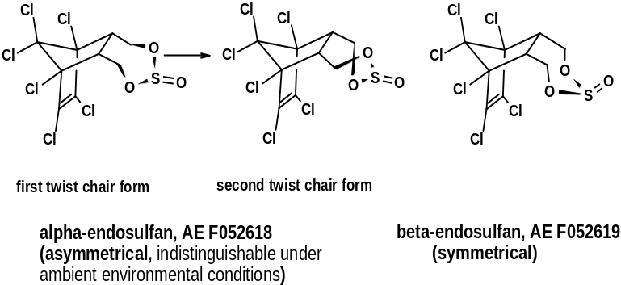

1.2 Physical-chemical properties
Endosulfan is a non volatile solid. The melting point of the isomeric mixture (99% content) covers a wide range between 76ºC and 124ºC.
Considering the vapour pressure and the Henry law constant, a higher volatilisation potential for the alpha than for the beta isomer is expected. The quotient vapour pressure vs. solubility in water suggests the alpha-isomer is about six times more volatile than the beta isomer.
The water solubility is below 1 mg/l for the isomers and the mixture. The partition coefficient is relatively high (log Pow > 4.7). Endosulfan is sensitive to acids, alkalis and moisture and subject to pH dependent hydrolysis to the diol (main hydrolysis product) and sulphur dioxide. Endosulfan is not flammable or auto flammable or explosive and does not have oxidising properties. There are some differences in the physical-chemical properties reported for the endosulfan isomers, the values included in Table 2 are those validated by the European Union.
Table 2. Physical-chemical properties of endosulfan isomers (Source European Union dossier, INIA, 1999-2004)
Melting point (state purity if not purified) | α - endosulfan: 109.2 ºC  β - endosulfan: 213.3 ºC
Appearance (state purity if not purified) | Flakes with tendency to agglomeration cream to tan mainly beige. Odour like sulphur dioxide.
Relative density (state purity if not purified) | 1.87 g / cm³
Vapour pressure (in Pa. State temperature) | α - endosulfan: 1.05 · 10⁻³ Pa  β - endosulfan: 1.38 · 10⁻⁴ Pa
Henry’s law constant (Pa m³ mol⁻¹) | α - endosulfan: 1.1 Pa · m³ · mol⁻¹ at 20 ºC.  β - endosulfan: 0.2 Pa · m³ · mol⁻¹ at 20 ºC.
Solubility in water | α - endosulfan: 0.41 mg · l⁻¹  β - endosulfan: 0.23 mg ·l⁻¹  No pH dependency observed
Solubility in organic solvents (in g/l or mg/l state temperature) | dichloromethane: 2007 g ·l⁻¹
 | ethyl acetate: 1009 g ·l⁻¹
 | ethanol (aprox) ≅ 65 g ·l⁻¹
 | n – hexane = 24 g ·l⁻¹
 | acetone = 1164 g ·l⁻¹
 | toluene = 2260 g ·l⁻¹
Partition co-efficient (log P_{ow}) (state pH and temperature) | log P_{ow} = 4.7  No pH dependence is observed.
Hydrolytic stability (DT₅₀) (state pH and temperature) | α - endosulfan T = 25ºC  pH 5: > 200 days
 | pH 7: 19 days
 | pH 9: 0.26 days
β - Endosulfan T = 25ºC
pH 5: > 200 days
 | pH 7: 10.7 days
 | pH 9: 0.17 days
Dissociation constant | According to the molecular structure Endosulfan cannot dissociate.
Photostability (DT₅₀) (aqueous, sunlight, state pH) | Photolitically stable
Quantum yield of direct photo transformation in water at λ > 290 nm | Photolitically stable
Flammability | Not capable of burning
Explosive properties | Non-explosive
The Czech Republic, has reviewed the data available in the international scientific literature for the Technical endosulfan, CAS No. 115-29-7, mixture of both isomers. These data are summarised below
Table 3. Physical-chemical properties of technical endosulfan (Czech Republic submission)
Melting point (°C): 70-124, recommended value: 106
Boiling point (°C): 106 (at 0.7 mmHg)
Density (g/cm3): 1.8
Water solubility (g/m3): 0.05-0.99, recommended value: 0.5
Vapor presure (Pa): 2.27E-5 - 1.3E-3, recommended value: 1.3E-3
H (Henry’s Law Constant) (Pa•m3/mol): 1.09-13.2, recommended value: 1.06
log KOW (Octanol/Water Partition Coefficient): 3.6
log KOA (Octanol/Air Partition Coefficient): 8.638, 8.677
log KOC (Sorption Partition Coefficient): 3.48-5.24, recommended: 4.09
These physical-chemical properties have been summarised by Canada (PMRA’s REV2007-13, page 12), setting the following main conclusions:
- Endosulfan α and β isomers as well as the major transformation product endosulfan sulfate are classified as sparingly soluble in water.
- Based on vapour pressures for the α and β isomers, calculated Henry’s law constants both endosulfan isomers have an intermediate to high volatility under field conditions and can be subject to long-range transport, this assessment is confirmed from available monitoring data. Endosulfan sulfate is considered relatively non-volatile under field conditions based on vapour pressure and Henry’s law constant.
- The ultraviolet/visible absorption spectrum indicated there are no significant absorption peaks in the natural sunlight region (290–800 nm) of the spectrum for either α or β isomers, for endosulfan sulfate and endosulfan diol; therefore, phototransformation is not expected to be an important route of transformation.

2. Summary information relevant to the risk profile

2.1 Sources

2.1.1 Production, trade, stockpiles
The most relevant information provided by the parties and observers is summarized below:
Albania
There is no any quantity of endosulfan in Albania. Following the directives from the European Union, Albania has prohibited endosulfan to be imported from February 2008.
Australia
Endosulfan is not produced or manufactured in Australia but technical active ingredient is imported (from eg. Israel or Germany) and formulated into four registered Australian products. The national sales of endosulfan (not production) in the last years are summarized below.
Quantity | Tonnes of active ingredient sold in the Australian market per year:  2004: 125.2 tonnes, 2005: 119.4 tonnes  2006: 116.4 tonnes, 2007: 74.1 tonnes  2008 (to mid-December): 89.9 tonnes
Location | Brisbane, Queensland
A small amount of endosulfan is formulated in Australia to be exported to New Zealand.
Austria
Endosulfan is not produced in Austria. The placing of Endosulfan on the Austrian marked in plant protection products was allowed from 1998 to 2006. After a period of grace product could be sold until June 2007. Endosulfan is listed in Annex I of the Commission Regulation (EC) No 1451/2007, thus biocidal products containing Endosulfan are forbidden in Austria since September 2006.
Bulgaria
Endosulfan has never been produced in Bulgaria.
Canada
Endosulfan is not produced in Canada.
Costa Rica
Costa Rica does not produce this substance. Endosulfan imported as active ingredient and as component of formulated products. The import figures for recent years are presented below.
Imports 2006: In the year 2006 92286 kilograms of Endosulfan active ingredient (a.i.) was imported, of these imports 59632 kg, a.i. in technical grade (TC) and the rest in formulated product at 35 to 36%. Of the product imported as TC a total of 170377 l of Endosulfan at 35% were formulated, plus the 93226 l of Endosulfan imported at 35%. We can therefore conclude that for this year the amount of active ingredient that entered the country would formulate 263603 l of commercial product at 35%.
Imports 2007: In the year 2007 42475 kilograms of Endosulfan active ingredient were imported, of these 20820 kg, a.i. technical grade (TC) and the rest of formulated product at 35 and 36%.
Of the product imported as TC a total of 59486 liters of Endosulfan at 35%, and the rest of the 61.825 liters of Endosulfan imported were formulated at 35%. For this year the imports were sufficient to formulate 121310 liters of commercial product at 35%.
The TC product is imported from countries like Hungary (1880 kg i.e.), India (2820), Germany (6724), China (9400). Of the product that was formulated at 35%, the imports come from the following countries: Guatemala (Bayer – 5291 kg i.e.) as Thiodan, Guatemala (Duwest- 596); Venezuela (1750), USA- 4200, Israel – 6772 as Thionex, Ecuador – 176, Belgium 1120, India – 4570, Hungary -1880, China – 9400.
Ecuador
Endosulfan is not produced in Ecuador.
Egypt
The uses and production of Endosulfan in Egypt has been banned since 1996 according to the ministerial decree No. 55/1996. The restriction includes: registrations, re-registrations, import, handling, manufacturing and productions.
Ghana
Ghana does not produce endosulfan.
Japan
Endosulfan has not been manufactured in Japan, but it has been imported for manufacturing the formulation products.
Lithuania
There are no data on endosulfan production, uses or placing on the market in Lithuania. There are no registered plant protection products in which endosulfan is as a constituent part.
Mali
Endosulfan is not produced In Mali. Endosulfan is imported but the imported quantities cannot be quantified.
Mauritius
Endosulfan has been used in the past but no records on used quantities are available. Currently endosulfan is not used in Mauritius; in fact, endosulfan is included in the list of agricultural chemicals that are banned from import, manufacture, use or process by the Dangerous Chemicals Control Act.
New Zealand
No manufacture in New Zealand, however, around 15000 – 20000 litres of endosulfan products (350 g/litre) are imported per year. Use has been declining in NZ over the past 10 years but no figures are available to quantify this. On 15 December 2008, the Environmental Risk Management Authority of New Zealand announced the revocation of all approvals for the import, manufacture or use of endosulfan products. This ban takes effect from 16 January 2009 and all existing stocks must be disposed of by 16 January 2010 (disposal can include export for destruction as hazardous waste or for use).
Nigeria
A national decision on regulatory action to stop further imports of endosulfan was taken at the 2007 National PIC meeting. Importers were given a moratorium of 3 years to comply.
The major importers have continuously assured the Government of their resolve to stop further imports of endosulfan, when the existent stock is exhausted.
Quantity in stock shall be determined from the on-going ASP Inventory activities.
Peru
Endosulfan is produced and imported in Peru, where endosulfan is registered as a plant protection product. Endosulfan is hold to the regulations established in the decision 436, Andean Norm for the Registration and Control of Chemical Pesticides of Agricultural Use.
Switzerland
There is no production of endosulfan in Switzerland. Endosulfan is registered in Switzerland as a plant protection product (insecticide) for control of various sucking insects. As of 31.12.2008, 10 products were known to be present on the Swiss market. In May 2007, Endosulfan was listed in Annex 8 of the Swiss Ordinance on Plant Protection Products. This means that the active ingredient Endosulfan is under review and that companies wanting to support the substance must notify this to the Federal Office for Agriculture.

2.1.2 Uses
The only reported use is as insecticide, mostly in agriculture. Endosulfan is successfully used for controlling numerous insect pests and some mites in a wide variety of different crops. It acts via the GABA receptor system (opening the chloride transport, increasing glutamate level). It penetrates into the insect via the tracheas, by ingestion, and has some contact activity. When applied to plants, endosulfan can penetrate into plant tissue without developing systemic action. The product is hydrolysed by aqueous alkalis and acids to produce endosulfan diol. The lethal effect on the insects may be seen only after several hours (12-24h), there is no “knock down effect”. The first symptom is mainly tremor.
Endosulfan is for use in arable crops and greenhouse use in agriculture, horticulture, orchards, forestry and nurseries. It controls harmful organism belonging to the following families: Aphids, White flies, Thrips, Lepidoptera, Peach twig and tree borer, Bugs, Psyllids, Coleoptera, Gall midge, Mites, Bud mites, Seed midge. The main metabolite endosulfan-sulfate has partly similar and partly less good efficacy compared to endosulfan. Resistance was reported for aphids in cotton, diamond backmoth in cabbage and cotton bollworm in parts of Australia.
Synergistic effects have been reported in combination with Bacillus thur. products, synthetic pyrethroids and Bauveria formulations.
The following parties and observers have submitted information on the current and past use patterns.
Albania
There is no any quantity of endosulfan used in Albania. Following the directives from the European Union, Albania has prohibited endosulfan to be imported from February 2008.
Australia
There are four registered endosulfan products in Australia for use on: canola, linseed, safflower, sunflower, cereals, cotton, chickpeas, cowpeas, pigeon peas, adzuki beans, faba beans, field peas, navy beans, mung beans, lupins, soybeans, cabbages, cauliflower, broccoli, beetroot, capsicums, okra, cape gooseberry, carrots, celery, cucurbits, egg plant, potatoes, sweet potato, taro, tomatoes, avocados, cashews, custard apple, citrus, guavas, persimmons, kiwi fruit, longans, loquats, lychees, macadamia nuts, mammey apples, mangoes, passion fruit, pawpaw, pecan nuts, pistachios, pome fruit, pomegranates, rambutans, sapodillas, tamarillos, native trees, shrubs, nursery crops, ornamentals, wildflowers, proteas and tobacco.
Austria
Endosulfan is listed in Annex I of the Commission Regulation (EC) No 1451/2007, thus biocidal products containing Endosulfan are forbidden in Austria since September 2006.
The placing of Endosulfan on the Austrian marked in plant protection products was allowed from 1998 to 2006. After a period of grace product could be sold until June 2007.
According to para. 25 of the Plant Protection Products Act (Federal Legal Gazette I No 60/1997) those persons responsible for the product authorization in Austria have to notify the quantity of the active substance placed on the Austrian market on a yearly base. The figures for Endosulfan according to the Federal Ministry of Agriculture, Forestry, Environment and Water Management are presented in the figure below.
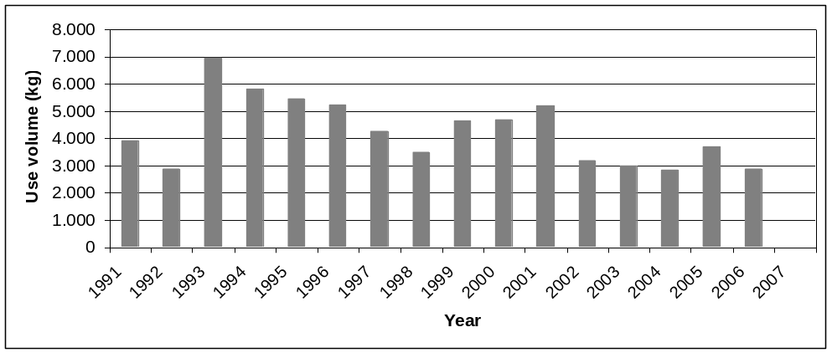
Figure 1. Figures for Endosulfan according to the Federal Ministry of Agriculture, Forestry, Environment and Water Management
Bulgaria
Endosulfan was used in agriculture as insecticide. Until the end of 1999, Endosulfan was imported and used as an active ingredient in the composition of two plant protection products “Thiodan 35 EC” and “Thionex 35 EC”, which authorisation for placing on the market expired at the end of 1999. No authorisations are given onwards.
Endosulfan is currently prohibited for production and placing on the market in Bulgaria
Canada
The following uses were phased out in Canada: alfalfa; clover; field corn; sunflower; spinach; greenhouse ornamentals; residential uses; succulent beans; succulent peas; and wettable powder uses on field tomatoes, sweet corn, dry beans and dry peas (Ref: PMRA’s REV2007-13).
Appendix IV of REV2007-13 lists endosulfan products registered in Canada. Appendix V lists the entire Commercial Class product uses for which endosulfan is presently registered. Appendix V shows which uses the registrant will continue to support, will no longer support or will partially support. Uses of endosulfan belong to the following use-site categories: greenhouse non-food crops, greenhouse food crops, terrestrial feed crops, terrestrial food crops, outdoor ornamentals, outdoor structural industrial sites (food processing plants) (Ref: PMRA’s REV2007-13, page 2).
Congo
Endosulfan is used in agriculture. From 1989 to 1989, 802255 liters of Endosulfan was imported. In 2002, 2300 liters of endosulfan was imported.
Costa Rica
Three pesticide formulation containing endosulfan are authorized by the Ministry of Agriculture.
The figure represents the imports in recent years, associated to the use as there is no production of endosulfan in Costa Rica.
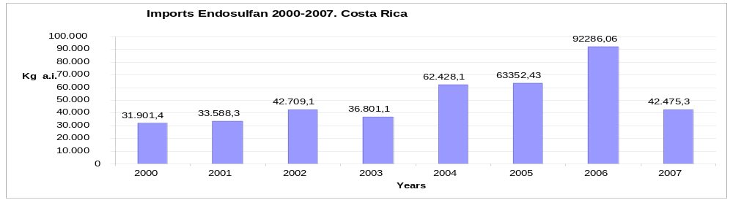
Figure 2. Endosulfan imports 2000-2007, Costa Rica
Croatia
Croatia has not been using endosulfan and products based on endosulfan since 01 July 2007.
Czech Republic
Endosulfan was used to the end of storage capacity until 31/12/2003. During the 1993-2000 period, endosulfan was used in order of ten’s to hundred’s kg per year. Some specific figures are presented below:
1997 - 23 kg | 1998 - 22 kg | 1999 - 11 kg
2000 - 176 kg (end of registration – usage to the storage capacity) |  | 2001 - 8 kg
31/12/2001 – end of registration, use to the end of storage capacity until 31/12/2003
Ecuador
Endosulfan is used as a pesticide and it is commercialized in Equator as an emulsifiable (35%) pesticide. Postregistration controls of the pesticide are performed regularly; however there is no vigilance on the use of endosulfan.
Egypt
The uses of Endosulfan in Egypt have been banned since 1996 according to the ministerial decree No. 55/1996. The restriction includes: registrations, re-registrations, import, handling, manufacturing and productions.
Ghana
Endosulfan is applied as a restricted insecticide for Cotton. Currently it is being phased out. The previous national imports (in liters) are as follows:
2005: 142920 L | 2006: 24000 L | 2007:60000 L
Honduras
Endosulfan is used as an agricultural Insecticide in a wide range of crops such as: coffee, (for the control of the drill of coffee), vegetables (tomato, pepper, broccoli, cauliflower, cucumber cabbage) potatoes, water melon, tobacco, bean, corn, sorghum, citric, banana tree, pineapple and others.
There are seven trademarks registered in Honduras with Endosulfan as an active ingredient (a.i) in its formulation: Endosulfan 36 EC, Thionex 35 EC, Thiodan 35 EC (1983), Barredor 50 WP and Endosulfan 35 EC (1997). Endosulfan 36 EC and Thiodan 33 CS (2005).
Importations: The mean quantity in Liters (L) for endosulfan in formulations that have been imported to the country in the last two years (2007-2008) is: 97362.50 L.
The main importers are: Bayer CropScience, Duwest Honduras, FENORSA. The countries of origin are Guatemala and Israel mainly.
Remark: In 1994 Endosulfan was restricted for its use in coffee crops, (Resol.0002-94 Secretaría de Agricultura y Ganadería) but by 1997 this chemical was released for being used in crops with US tolerance established by EPA. Endosulfan cannot be used in crops by flood such as rice. (Resol. 0004-97 Secretaría de Agricultura y Ganaderia)
Japan
Formulation products with Endosulfan have been used as agricultural insecticide since 1960.
For reference, total shipping volume of Endosulfan in the past five years in Japan;
(*The volume is converted from shipping volume (t) of the formulation products with content rate of Endosulfan.)
 | 2003 | 2004 | 2005 | 2006 | 2007
Total shipping volume (kg) of Endosulfan | 16,400 | 16,800 | 17,400 | 15,000 | 14,500
Lithuania
There are no registered plant protection products in which endosulfan is a constituent part.
Mali
Endosulfan is an organochlorine insecticide used against aphids, thrips, beetles, larvae that feed on leaf tissue, mites, borers, worms gray cotton caterpillars, white flies and leafhoppers. It is used on cotton, tobacco, cantaloupe, tomatoes, squash, eggplant, sweet potatoes, broccoli, pears, pumpkin, corn, cereals, oilseeds, potatoes, tea, coffee, cocoa, soybeans and other vegetables. However, it should be noted that in CILSS countries, endosulfan is mainly used on cotton.
Mauritius
Endosulfan has been used in the past but no records available. Currently not used in Mauritius; Endosulfan is included in the list of agricultural chemicals that are banned from import, manufacture, use or process by the Dangerous Chemicals Control Act.
Nigeria
Endosulfan has been used for controlling pests in a wide variety of crops including cotton.
Norway
No uses. Use banned since 1.1.1999. It is prohibited to stock, sell and use endosulfan as a pesticide.
Peru
Endosulfan is used mainly as an agriculture pesticide in Peru.
Romania
The uses of the formulation products of endosulfan in Romania from 2005 to 2007 are summarized in the table below:
Slovak Republic
Active substance Endosulfan is not contained in plant protection products used in Slovakia. In accordance with information from national authorities 2 kg plant protection products THIODAN 35 EC has been used in whole Slovak Republic in agriculture in 2001. That means it was approximately 1 kg of active substance. Amount 55 kg of this plant protection products have been in stocks in Slovakia to the date 1 October 2008.
New Zealand
Endosulfan is used as insecticide on certain vegetable, citrus and berry fruit crops, and on ornamentals. Also used for earthworm control on turf on golf courses, sports fields, airports, etc.
Switzerland
Endosulfan is registered in Switzerland as a plant protection product (insecticide) for control of various sucking insects. As of 31.12.2008, 10 products were known to be present on the Swiss market. In May 2007, Endosulfan was listed in Annex 8 of the Swiss Ordinance on Plant Protection Products. This means that the active ingredient Endosulfan is under review and that companies wanting to support the substance must notify this to the Federal Office for Agriculture.
Togo
Endosulfan is used as pesticide in TOGO to protect cash crops like cotton against Helicoverpa amigera and Coffee against Hypotenemus hampei. The use of Endosulfan in cotton cultivation is also reported in BENIN (in 2007 Some 256000 liters were ordered but only 50000 liters were provided; recently in 2008 a private provider company in Benin has issued a tender of 20000 litres)
USA
In the USA Endosulfan was registered only for agricultural uses and US EPA estimates that some 1.38 million lb (ca. 625,000kg) were used annually from 1987 to 1997.
US exported more than 300, 000 lbs (ca. 135,900kg) of Endosulfan from 2001-2003 mostly to Latin America.

2.2 Environmental fate

2.2.1 Persistence
Endosulfan is a labile bicyclic sulphite diester with an additional moiety containing a hexachloronorbornene ring. The technical product is a mixture of two isomers (α endosulfan and β endosulfan) which differ in the configuration of the isomer SO₃ group and the respective ring.
Endosulfan aerobic degradation occurs via oxidation. The main metabolite formed is endosulfan sulfate. This compound is slowly degraded to the more polar metabolites endosulfan diol, endosulfan lacton, endosulfan ether. Formation of endosulfan sulfate is mediated essentially by micro-organisms, while endosulfan-diol was found to be the major hydrolysis product. Microbial mineralisation is generally slow.
Endosulfan sulfate also posseses insecticidal activity. Given the comparable toxicity of the sulfate metabolite a number of authors make use of the term “endosulfan(sum)” which includes the combined residues of both isomers of the parent and endosulfan sulfate. However, this term does not consider that in reality all the metabolites resulting from the degradation of endosulfan sulfate maintain a similar chemical structure with the hexachloronorbornene bicycle.
The following degradation patterns for soil and water are proposed in the European Union risk assessment. The conclusion for aerobic soil degradation in the EU risk assessment is as follows: The mineralization of endosulfan is < 5%. Main metabolite is endosulfan sulfate that has a mineralization between 11.01% and 13.08%. These facts suggest a potential high persistence of a soil residue constituted by a number of chlorinated metabolites, which may not account individually for more than 10% of applied dose but that all together may represent high amount of it. Based on their chemical structure it may be expected that the physicochemical properties of these compound will be similar and generally persistent and bio-accumulable. Therefore, a wider investigation of the degradation routes of this compound must be done.

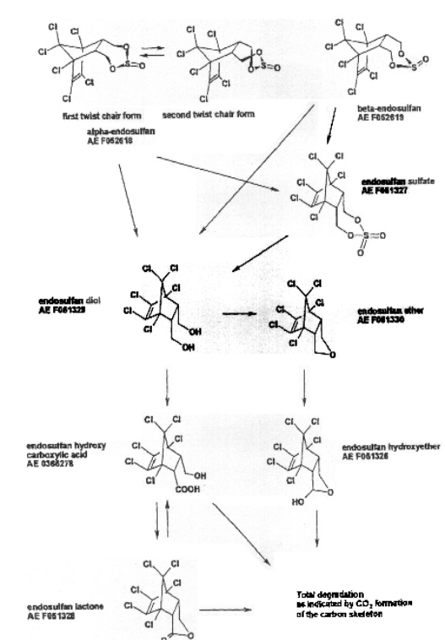
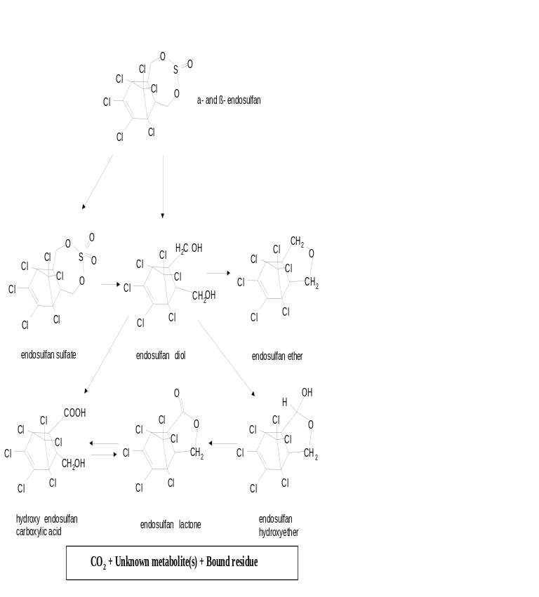
Figure 4. Transformation of endosulfan
This environmental fate complicates the assessment of persistence expressed by DT₅₀ values. Most studies suggest that alpha-endosulfan has a faster degradation than beta-endosulfan, and than endosulfan sulfate is much more persistent. There is a large variability in the reported DT₅₀ values for these substances. In the European Union assessment, the reported DT₅₀ for aerobic soil degradation under laboratory conditions, ranged from 25 to 128 days for the alpha + beta isomers, and from 123 to 391 for endosulfan sulfate. The dissipation under field conditions also varies largely; the European Union assessment reported, for the temperate regions, field DT_{50s} ranging from 7.4 to 92 days for the alpha + beta isomers. A fast dissipation has been observed for tropical climates; volatilization, particularly for the alpha and beta isomers, is considered the major process for endosulfan dissipation under these conditions (Ciglasch et al., 2006; Chowdhury et al., 2007). Field aging increases the persistence in soil and is particularly relevant for endosulfan, with a 3-fold increase in the apparent K_{OC} within 84 in a tropical fruit orchard under natural weather conditions (Ciglasch et al., 2008).
At the fourth POPRC meeting, the combined DT₅₀ measured in laboratory studies for alpha and beta endosulfan and endosulfan sulfate, was selected as a relevant parameter. A large variability on the rate of this degradation has been observed. The estimated combined half-life in soil for endosulfan (alpha, beta isomers and endosulfan sulfate) typically ranges between 28 and 391 days; but higher and lower values are reported in the literature under specific conditions.
In the aquatic compartment, endosulfan is stable to photolysis; a rapid hydrolysis is only observed at high pH values, and it is non-readily degradable. The studies by Jones (2002; 2003) reported in the EU dossier present useful information for the degradation/dissipation of endosulfan in water/sediment systems. The studies suggest DT_{50s} for the alpha, beta isomers and endosulfan sulfate ranging between 3.3 and 273 days. These figures cannot be validated as no dissipation of endosulfan sulfate was observed in the sediment. The following conclusions were proposed after and in-depth evaluation of the available information:
- The dissipation of endosulfan and the abundance of one or other degradation products is influenced by the pH and other properties of the water/sediment system.
- Regarding the metabolites, the accumulation of endosulfan sulfate in the sediment and of endosulfan hydroxy carboxylic acid in water has been seen throughout the studies. The degradation rate could not be estimated, but DT₅₀ > 120 d has been demonstrated. Endosulfan diol was also detected at levels over 10% Total Applied Radioactivity, but dissipation was observed. Under acidic conditions endosulfan lactone seems to accumulate in the sediment not reaching a plateau after one year.
The dissipation in tropical water/sediment systems have been recently studied (Laabs et al., 2007). A medium-term accumulation in the sediment of tropical ecosystems can be expected for endosulfan isomers. The authors conclude that the persistence of endosulfan and other pesticides in aquatic ecosystems of the tropics is not substantially lower than during summer in temperate regions.
There is a high uncertainty on the degradation rate of endosulfan in the atmosphere. Buerkle (2003), has presented a set of estimations based on Structure Activity Relationship and experimental value. A half file in atmosphere using the Atkinson method was conducted in 1991, resulting in a value of 8.5 d but with high uncertainty. Experimental figures are presented for alpha-endosulfan (27 d at 75ºC for flashlight photolysis) and beta-endosulfan (15 d based on the Freon-113 method). The AOPWIN calculation method indicates a half life of 47.1 hours assuming a constant diurnal OH concentration of 5 ·10⁵ cm⁻³.

2.2.2 Potential for bioaccumulation
Three complementary information blocks have been analysed for assessing the bioaccumulation and biomagnification potential of endosulfan and its degradation products: the screening assessment based on physical-chemical properties; the analysis of experimental data, including bioconcentration, bioaccumulation and toxicokinetic studies; and the analysis of field collected information. The key elements of these assessments are presented below.
Screening assessment based of physical-chemical properties
The reported log K_{ow} for alpha- and beta-isomers and endosulfan sulfate range between 3 and 4.8. A new determination provided by the industry (Muehlberger and Lemke, 2004) using the HPLC-method resulted in a log K_{ow} of 4.65 for α-endosulfan, and a log K_{ow} of 4.34 for β-endosulfan under neutral conditions. The K_{ow} of endosulfan sulfate resulted in a log K_{ow} of 3.77. The other metabolites included in the K_{ow} determination have lower K_{ow} than endosulfan sulfate. These values indicate potential for bioconcentration in aquatic organisms, although they are below the screening trigger of the Stockholm Convention.
Recently, the role of the octanol/air partition coefficient K_{oa} for the screening assessment of the biomagnification potential of POPs in terrestrial food chains is receiving a significant attention. Current criteria for identifying bioaccumulative substances based on K_{ow} only apply to water-breathing organisms and are inadequate for protecting air-breathing organisms including mammals, birds, and human beings (Armitage and Gobas, 2007); and K_{oa} should be incorporated in the screening criteria and in bioaccumulation models (Powell et al., 2008)
Kelly & Gobas (2003) and Kelly et al. (2007) have proposed that the biomagnification of endosulfan in the terrestrial food chain is particularly relevant, because it has a high log K_{oa}. A high K_{oa} causes slow respiratory elimination.
The following values are proposed:
- log K_{oa} alpha-Endosulfan = 10.29
- log K_{oa} beta-Endosulfan = 10.29
- log K_{oa} Endosulfan sulfate = 5.18
Although there are no specific screening thresholds for the K_{oa}, the authors suggests that organic chemicals with a log K_{ow} higher than 2 and a log K_{oa} higher than 6 have an inherent biomagnification potential in air-breathing organisms of terrestrial, marine mammalian, and human food chains. Endosulfan clearly falls within this category.
Bioconcentration studies in aquatic organisms
The reported BCF values for fish ranged from approximately 20 to 11600 (kg⁻¹ wet wt.); however, the 11600 value is considered of low reliability. A BCF of 5670 has been proposed from a re-evaluation of this study, but the uncertainty is still too high and the data should not be considered as reliable. The USEPA re-evaluated in 2007 the bioconcentration studies.
The review (USA additional information) (U.S. EPA 2007) covered seven fish species: sheepshead minnow (Cyprinodon variegatus), zebra fish (Brachydanio rerio), yellow tetra (Hyphessobrycon bifasciatus), striped mullet (Mugil cephalus), pinfish (Lagodon rhomboids), long whiskers catfish (Mystus gulio), and spot (Leiostomus xanthurus). According to the U.S.EPA, the methodology in these studies did not meet all of the standard criteria (i.e., achieved steady-state, measurement and stability of exposure concentrations, analytical confirmation of parent and metabolites) for a bioconcentration study under the Federal Insecticide, Fungicide and Rodenticide Act (FIFRA). The two highest quality studies, based on meeting some of these three criteria, indicate that the BCF range for fish is 1000 (striped mullet; Schimmel et al. 1977) to 3000 (sheepshead minnow; Hansen and Cripe 1991). Depuration halflives in fish for α- and β-endosulfan and endosulfan sulfate were 2–6 days. Bioconcentration studies were available for five species of invertebrates: blue mussel (Mytilus edulis), grass shrimp (Palaemonetes pugio), oyster (Crassostrea madrasensis), clam (Katelysia opima), and red swamp crayfish (Procambarus clarkii). Bioconcentration studies with invertebrates and endosulfan indicate a BCF range of 12–600.
The Figure below, present the USEPA summary table on bioconcentration data.
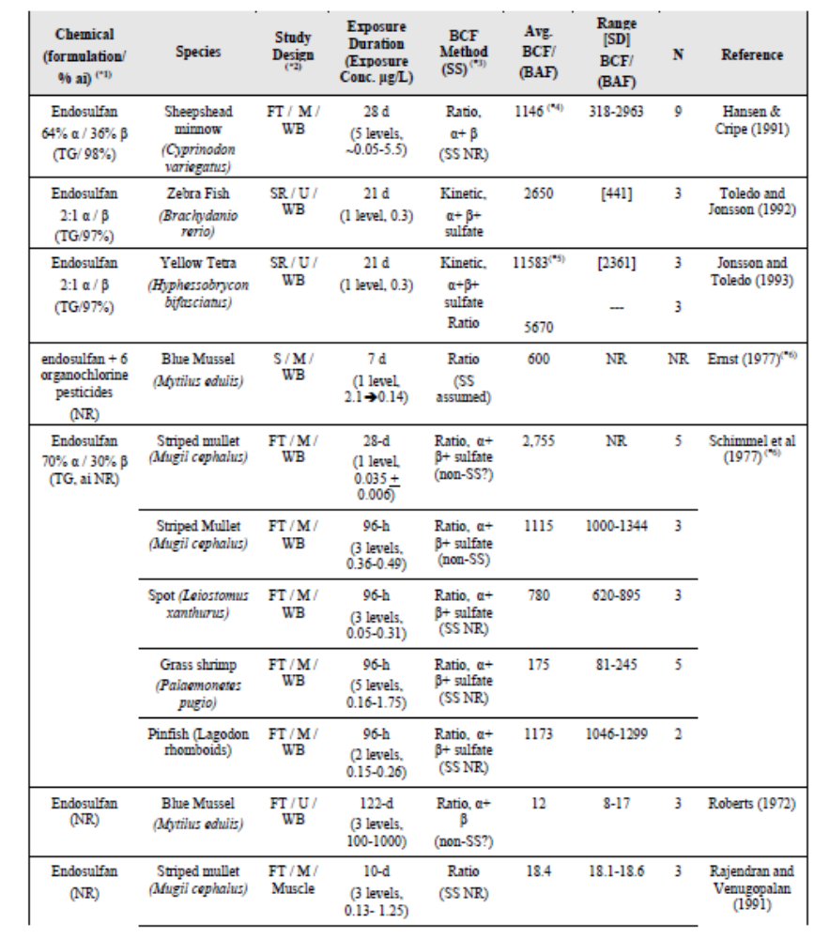
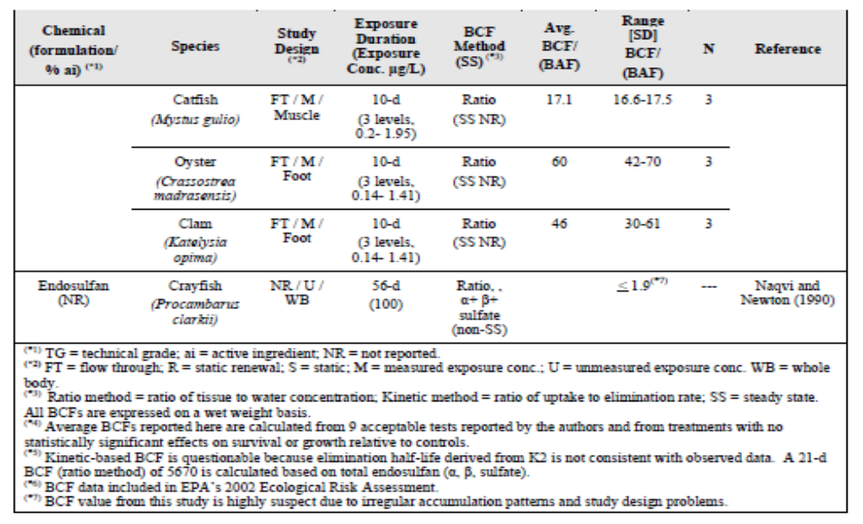
An average BCF of 2682 and 3278 dry weight was determined for freshwater green algae (Pseudokirchneriella subcapitatum) and the cladoceran Daphnia magna, respectively (DeLorenzo et al. 2002). D. magna neonates accumulated little endosulfan when exposed via the ingestion of contaminated phytoplankton. Therefore, it appeared that uptake from water is the dominant route for endosulfan bioconcentration in zooplankton. Information on depuration in invertebrates was limited.
The assessment of parent and metabolite bioconcentration is particularly relevant. The study by Pennington et al., (2004) offers a good example on the complexity of these estimations. Oysters were exposed to endosulfan in an estuarine mesocosm for 96h. Within this short exposure period, a significant bioaccumulation of alpha- and beta-endosulfan in oysters is observed; but the quantification, even under mesocosm controlled conditions, is very different depending on how the water and organisms concentrations are compared. The authors suggest BCFs between 375 and 1776 dry weight for total (alpha-, beta- and endosulfan sulfate).
An outdoor aquatic microcosms study has been presented in the CropLife dossier. (Schanne, 2002) The objectives of this freshwater field test were the following:
- Fate and relative distribution of 352 g·l⁻¹ EC formulated α,β-Endosulfan and its metabolites in major compartments of outdoor aquatic ecosystems after application as simulated realistic spray drift and run-off.
- Investigation of acute and sublethal effects on bluegill sunfish (Lepomis macrochirus) including fish residue analysis.
- Analysis of the community of sediment-dwelling organisms at test end, including residue analysis in these organisms and various compartments of the sediment.
The study was conducted outdoor in order to simulate the conditions in natural systems as closely as possible. For that purpose, sediment, water and other biota were collected from a large shallow water, natural reserve area from the Austrian part of the Lake Constance.
The test design was based on consensus methods proposed by experts at four meetings convened with Europe and North America (SETAC-Europe, 1991; SETAC/RESOLVE, 1991; EWOFFT, 1992; World Wildlife Fund/RESOLVE, 1992; Hill et al., 1994). In addition, the stipulations of the OECD draft guideline document “Freshwater Lentic Field Test” (OECD, 1996) were considered, as well as information provided by European Regulatory Bodies.
The study was conducted as a 7 concentration dose-response study with 4 control systems per application route between August and October 1998: [14C]-α,β-Endosulfan was formulated as emulsifiable concentrate (352 g·l⁻¹ endosulfan THIODAN) and applied up to 3 times to 1 m³ outdoor microcosm system stocked with 50 juvenile, caged bluegill sunfish. Treatments were performed in increments of two weeks. For spray-drift simulation, the formulation was sprayed homogeneously over the water surface. For run-off simulation, the formulation was applied onto a soil layer, which was aged for one day and applied as soil slurry over the water surface. The identification of the test groups is based on the target concentrations of 0.27, 0.47, 0.84, 1.51, 2.68, 4.64 and 8.38 μg·l⁻¹ for the spray drift application and 0.21, 0.42, 0.84, 2.09, 4.19, 6.29 and 8.39 μg·l⁻¹ for the run-off application.
The following table summarizes the nominal treatment levels, based on the concentrations measured in the stock solutions, given as average per treatment:
Test group | SD-0.27³ | SD-0.47³ | SD-0.84³ | SD-1.51³ | SD-2.68³ | SD-4.64² | SD-8.38¹
Concentration (μg ai/l) | 0.34 | 0.55 | 1.16 | 1.96 | 3.50 | 6.40 | 10.33
Concentration (μg EC/l) | 1.03 | 1.67 | 3.53 | 5.96 | 10.64 | 19.45 | 31.4
Drift rate (% of the MRFR) | 0.4% | 0.7% | 1.4% | 2.3% | 4.2% | 7.6% | 12.3%
Test group | RO-0.21³ | RO-0.42³ | RO-0.84³ | RO-2.09³ | RO-4.19³ | RO-6.29² | RO-8.39¹
Concentration (μg SR/l) | 0.21 | 0.42 | 0.84 | 2.09 | 3.99 | 6.29 | 8.39
Concentration (μg EC/l) | 0.64 | 1.28 | 2.55 | 6.35 | 12.13 | 19.12 | 25.5
Run-off rate (% MRFR) | 0.05% | 0.1% | 0.2% | 0.5% | 1% | 1.5% | 2%
^{1,2,3} one, two, three treatments at intervals of two weeks; SD; Spray-drift; RO: Run-off; SR: Soil residue after one day ageing (=total endosulfan + metabolites (if any)), EC: Emulsifiable Concentrate (Thiodan 352g·l⁻¹); MRFR: maximum Recommended Field rate; ai: active ingredient.
Regular observations and sample collection was conducted for 6 weeks. At test end, large samples of water, sediment, macrophytes and tank wall periphyton were collected in order to calculate a mass balance. Furthermore, sediment cores were subdivided into various layers. From these, the residue in the water-sediment interface, pore water, sediment and sediment dwelling organisms were analysed. The populations of sediment-dwelling organisms were taxonomically investigated. All samples taken during the test and at test termination were analysed for their total radioactive residue. Selected samples were characterized by chromatographic methods: C18-HPLC-UV/RAM and radio-TLC.
The concentrations of endosulfan lactone, and two unknown metabolites, M1 and M4, in water increased constantly during the study, whereas endosulfan sulfate was more or less constant at a low level or slightly decreasing at both entry routes. The total radioactive sediment residue (TRR sediment) was increasing during the study to maximum 13.8 μg radioactivity equivalents/kg. The same is valid for all components of the residue. The total radioactive residue in macrophytes (TRR macrophytes) increased constantly during time to maximum 2236 μg radioactivity equivalents/kg fresh weight. Like for macrophytes, the total radioactive residue in surviving fish (TRR fish) was high at maximum 3960 μg radioactivity equivalents/kg fresh weight. The following table summarizes the percent contribution of the metabolites to the corresponding TRR:
Unit | %
Identity | TRR¹ water |  | TRR² sed |  | TRR³ macrophyte |  | TRR³ fish
Test group | SD-2.68 | RO-4.19 | SD-2.68 | RO-4.19 | SD-2.68 | RO-4.19 | SD-2.68 | RO-4.19
M1 | 16.7 | 26.2 | 0.9 | 1.1 | ND | ND | 8-13 | 12-16
M5 | ND | ND | ND | ND | ND | ND | 16-25 | 21-27
Endosulfan diol | 26.3 | 28 | 38.3 | 19.7 | 18.9 | 13.4 | 2-3 | 1-2
Endosulfan hydroxy ether | 19.2 | 17.4 | 15.3 | 6 | 9.7 | 8.2 | 1-3 | 4
Endosulfan lactone | 23.4 | 17.4 | 8.7 | 5.1 | ND | ND | ND | ND
M4 | 3.9 | 3.8 | 0.7 | 1.2 | ND | ND | ND | ND
Endosulfan sulfate | 4 | 4.8 | 25.6 | 23.7 | 16.7 | 22.3 | 41-49 | 39-47
β-Endosulfan | ND | ND | 5.4 | 20.5 | 0.9 | 0.9 | 8 | 4-7
α-endosulfan | ND | ND | 5.1 | 20.9 | 2.9 | 0.9 | 5 | 4
α,β-Endosulfan | ND | ND | 10.5 | 41.3 | 3.8 | 1.8 | 12-13 | 8-12
M6 | ND | ND | ND | ND | 1.9 | 13.5 | ND | ND
M7 | ND | ND | ND | ND | 7.8 | 6 | ND | ND
M8 | ND | ND | ND | ND | 5 | 4.2 | ND | ND
M9 | ND | ND | ND | ND | 26.9 | 19.7 | ND | ND
ND not detected; SD: Spray drift; RO: Run-off; ¹ test end (days 42/43); ² day 35/34; ³ at maximum residue level.
The study was evaluated within the EU regulatory assessment for plant protection products. The main conclusions are presented below.
This study clearly demonstrates that endosulfan is degraded to metabolites that maintain the chlorinated cyclic structure of endosulfan. These metabolites have the potential of bioaccumulation in fish and macrophytes, and some of them have been demonstrated their potential for persistence in the environment. In addition to this, the study reveals that there are other unknown metabolites with the same potential of bioaccumulation.
The estimated bioaccumulation factors for spray-drift and run-off routes are:

BAF total radioactivity ca.1000.
BAF endosulfan-sulfate = 4600 - 5000 (spray-drift)
BAF endosulfan-sulfate = 2900 (run-off)
BAF macrophytes for endosulfan-sulfate = 1000 (spray-drift)
BAF macrophytes for endosulfan-sulfate = 750 (run-off)
It should be noted that these BAFs should be taken with care as the tested concentrations provoked clear effects on aquatic organisms or were too close to toxic concentrations; therefore, the estimated bioaccumulation potential could be different (usually lower, but occasionally higher) to that expected due to the toxic effects of the tested concentrations.
Considering the overall information, it is concluded that this study only allows estimating the risk of active ingredient, not the metabolites. An Ecologically Acceptable Concentration can not be determined based on the results of this study due to the long-term effects of the metabolites can not be established.
Toxicokinetic and metabolism studies
Following oral administration of endosulfan, either via single dose or dietary administration, elimination of the parent compound and its metabolites is extensive and relatively rapid in a range of species of experimental animals. In rats and mice, recovery of radiolabelled test material was generally greater than 85% of the administered dose, with a majority of this excretion occurring within a few days of administration. Excretion in rodents was mainly in the faeces, with a smaller amount excreted in the urine. Similarly, elimination of endosulfan was extensive in goats (>90%), with about 50% recovered in the faeces and 40% in the urine.
In mice endosulfan and its sulfate and diol metabolites were the major faecal excretion products, with the diol metabolite excreted in the urine, while in rats, biliary excretion was extensive (up to 50%), and there was little enterohepatic circulation from the bile. There does not appear to be appreciable bioaccumulation of endosulfan residues in body tissues, with only trace amounts of endosulfan residues found in most tissues, including the fat, of most species. In Wistar rats, kidney and liver residues were highest, although the half life for residues in these organs was only 7 days and 3 days, respectively, and kidney residues were also higher than other tissues in goats. No residues of endosulfan or its metabolites in cow or sheep milk were detected.
The metabolites of endosulfan include endosulfan sulfate, diol, hydroxy-ether, ether, and lactone but other metabolites are polar substances which have not yet been identified.
Dermal absorption studies in vivo (rats and monkeys) and in vitro (human/rats) were performed. They suggest that initial absorption is dose related, movement through skin is low (occurring over 168 h in the rat in vivo study), endosulfan continues absorbed from skin reservoirs after skin washing and penetration as per cent rate is lower in human skin than rat skin. Dermal absorption was reported to be as high as 25% in rats, and about 20% in Rhesus monkeys.
A physiologically based pharmacokinetic model for endosulfan in the male Sprague-Dawley rats has been developed by Chan et al. (2006). The PBPK model was constructed based on the pharmacokinetic data of our experiment following single oral administration of ¹⁴C-Endosulfan to male Sprague-Dawley rats. The model was parameterized by using reference physiological parameter values and partition coefficients that were determined in the experiment and optimized by manual adjustment until the best visual fit of the simulations with the experimental data were observed. The model was verified by simulating the disposition of ¹⁴C-Endosulfan in vivo after single and multiple oral dosages and comparing simulated results with experimental results. The model was further verified by using experimental data retrieved from the literature. According to the authors, the model could reasonably predict target tissue dosimetries in rats.
Recently, the accumulation and elimination kinetics of dietary endosulfan in Atlantic salmon (Salmo salar) has been published (Berntssen et al., 2008). The study focused on the carry-over of dietary endosulfan to the fillet of farmed Atlantic salmon. The uptake and elimination rate constants of the alpha and beta isoform of endosulfan were determined in seawater adapted Atlantic salmon (initial weigh 173+/-25 g) fed on endosulfan enriched diets (724 and 315 microg kg⁻¹ for alpha- and beta-endosulfan, respectively) for 92 days, followed by a 56 days depuration period with feeding on control diets (<0.3 microg kg⁻¹ endosulfan). The accumulation of the toxic metabolite endosulfan sulfate, which was not detected (<0.5 microg kg⁻¹ ) in the experimental feeds, was also determined. Dietary beta-endosulfan was more persistent than alpha-endosulfan as demonstrated by a higher uptake (41+/-8% vs. 21+/-2%) and lower elimination (26+/-2 x 10⁻³ day⁻¹ vs. 40+/-1 x 10⁻³ day⁻¹) rate constants, and a higher biomagnification factor (0.10+/-0.026 vs. 0.05+/-0.003, p<0.05). Based on the decrease in diastereometric factor over time, biotransformation was estimated to account for at least 50% of the endosulfan elimination. The formation of the metabolite endosulfan sulfate comprised a maximum 1.2% of the total accumulation of endosulfan.
Metabolism of endosulfan was observed in all studies. The assessment of these metabolic processes represents a main issue for a proper assessment of the bioaccumulation potential of endosulfan, as the metabolites maintain the chemical structure and some of them are of toxicological relevance.
The proposed degradation patterns in plants, mammals and birds are presented in the following figures:
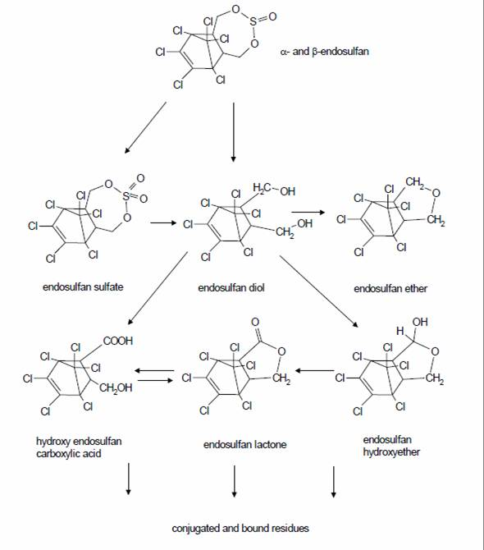
Figure 5. Proposed degradation pathway of endosulfan in plants (EU Dossier, INIA, 1999-2004)

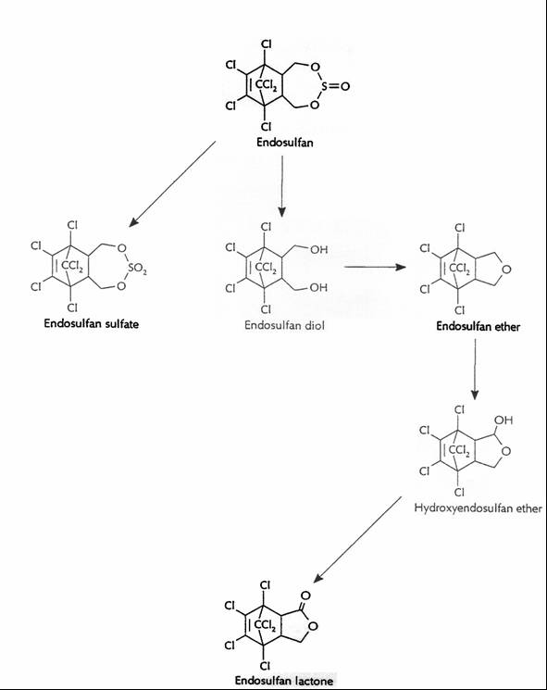
Figure 6. Proposed degradation pathway of endosulfan in domestic mammals (cow) and birds (hen) (EU Dossier, INIA, 1999-2004)
It should be noticed that the same metabolites are formed in environmental compartments and biota.
Assessment of field data and biomagnification models
A large number of studies offering information on measured levels of endosulfan in biota all over the world are available. Endosulfan and its metabolite endosulfan sulfate are frequently found in crop and vicinity areas, as well as in remote areas where the presence of this pesticide is related to medium and long range transport from those areas in which endosulfan has been used.
The quantitative estimation of the biomagnification potential of endosulfan from biota values measured in the field is complex, due to degradation and metabolism. The degradation pathways in the environmental compartments water, sediment and soil, and the metabolic pathways in plants and animals lead to a complex matrix of the same endosulfan related metabolites. As a consequence, if metabolites are not accounted for, the biomagnification potential can be underestimated. On the other hand, the bioaccumulation of the endosulfan metabolites can be related to the exposure to the parent, with absorption and further metabolism and bioaccumulation, and/or the direct exposure to the metabolites with the subsequent accumulation in the organisms.
Most studies focus on alpha-, beta- and endosulfan sulfate; as a consequence a full assessment covering all relevant metabolites cannot be conducted.
Quantitative biomagnification estimations can be obtained through the use of mathematical models calibrated with field data (Alonso et al., 2008). Several published models indicate the potential biomagnification of endosulfan through the food chain.
A model of the lichen-caribou-wolf food chain predicts biomagnification of beta-endosulfan based on the importance of high octanol-air partitioning coefficient (log K_{oa}) and despite a relatively low octanol-water partitioning coefficient (log K_{ow}), was developed by Kelly et al. (2003). The BMFs for wolf range from 5.3 to 39.8 for 1.5 to 13.1 year old wolves.
A particularly relevant piece of information was published in 2007 (Kelly et al., 2007).
The authors developed and calibrated a food-web biomagnification models for persistent organic pollutants, including marine and terrestrial food-webs. The figure below, shows a comparison of predicted versus observed concentrations for a range of species from the Canadian Artic.

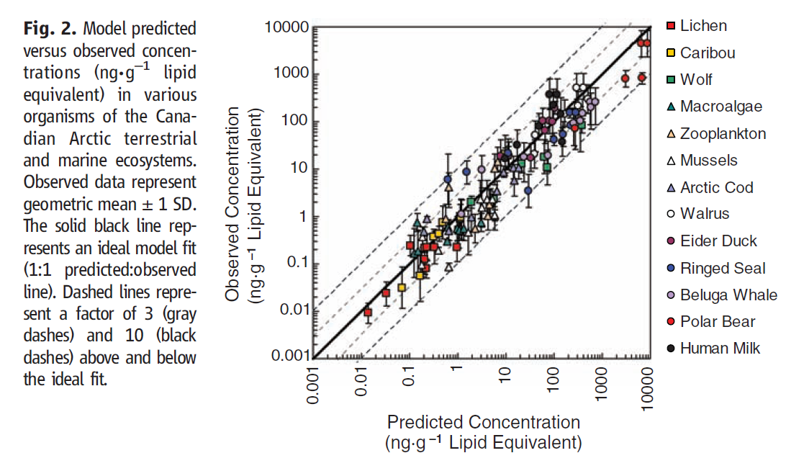
Fig.7
The model predicts a significant biomagnification potential of beta-endosulfan in all air-breathing species, ranging from 2.5 for terrestrial herbivores to 28 for terrestrial carnivores; and biomagnification factor below 1 for water-respiring organisms.
Also in the Canadian Artic (concentrations of alpha-, and beta-endosulfan and endosulfan sulfate in ice-algae, phytoplankton, zooplankton, marine fish and ringed seal have been presented. Concentrations ranged from 0.1 – 2.5 ng·g⁻¹ lipid. Log BAFs of 5.3 – 6.6 were calculated for planktons and fish. Calculated trophic magnification factors were less than 1, suggesting no biomagnification in the ringed seal food chain (Morris et al. 2008). It should be noted that these reported BAFs are much higher than those published by other authors; unfortunately the reference is from a presentation and is not available.
The comparison of reported concentrations of endosulfan in biota, and particularly in top predators, with those observed in the same organisms and ecosystems for other POPs, also offer indirect indications of bioaccumulation potential.

2.2.3 Long range rransport
The potential of endosulfan for long range transport can be evaluated from three main information sources, the analysis of the endosulfan properties, the application of LRT models, and the review of existing monitoring data in remote areas.
Screening of physical-chemical properties
Specific physicochemical properties that are critical to understanding the movement of a chemical through the abiotic and biotic environment include water solubility, vapor pressure (VP), Henry’s Law constant (H), dissociation constant (pKa), partition coefficients including octanol-air (K_{oa}) and octanol-water (K_{ow}), and the sorption coefficients of soil and sediment (K_{oc}). These properties are responsible for a chemical’s propensity to move from one environmental compartment to another and influence its susceptibility to additional abiotic and biotic degradation processes. The relevance of each property for assessing the potential for long range transport varies for each route. Atmospheric long-range transport has been recognized as a main route for most POPs, regulating its movement from the temperate and tropical areas to the coolest regions of the planet: the Artic, Antarctica and mountain areas. Volatilization, persistence in air, and overall persistence are recognized as the most relevant parameters regulating these processes. Previous discussions at the POPRC, have recognised the potential role of other long-term transport mechanisms, particularly those associated to the movement of particle-bound chemicals, either through the atmosphere or the marine environment.
Transformation or degradation reactions such as biodegradation, hydrolysis, and photolysis in various media are important, however, they may also result in degradation products that are more persistent and/or toxic than the parent. This situation is particularly relevant, as well as problematic, in the case of endosulfan, considering the persistence of the main metabolite, endosulfan sulfate, and the further degradation, by abiotic and biotic processes occurring in exposed organisms as well as in the environment, in a number of additional metabolites all of them maintain the endosulfan structure. The information on these metabolites, which could be formed in the use areas, being the subject to long range transport, or produced in the remote areas as a consequence of the degradation of the parent endosulfan, is scarce.
There is enough information on the volatility of alpha and beta endosulfan for supporting the potential for atmospheric transport. The atmospheric transport at long distances requires a minimum level of persistence in the atmosphere; as presented above, there is a high uncertainty on the real degradation rate of endosulfan in this compartment but all reported values are above or very close to the threshold, a half life of 2 days. Taking into account the much lower temperatures of the troposphere, the environmental half life of endosulfan under real situations might even be longer. Therefore, it should be concluded that the combination or a high volatility and sufficient atmospheric persistence may result in a significant potential for long range transport.
LRT model predictions
Several models have been developed for estimating this potential according to the characteristics of the POP candidate molecules. Becker, Schenker and Scheringer (ETH, 2009 Swiss submitted information) have estimated the overall persistence (POV) and long-range transport potential (LRTP) of alpha- and beta-endosulfan and two of their transformation products, endosulfan sulfate and endosulfan diol with two multimedia box models, the OECD POV and LRTP Screening Tool and the global, latitudinally resolved model CliMoChem. The OECD Tool yields POV and LRTP for each compound separately, whereas the CliMoChem model calculates the environmental distribution of the parent compounds and the formation and distribution of the transformation products simultaneously. Results from the CliMoChem model show that POV and LRTP of the endosulfan substance family are similar to those of acknowledged Persistent Organic Pollutants, such as aldrin, DDT, and heptachlor. The results also show that POV and LRTP of the entire substance family, i.e. including the transformation products, are significantly higher than those of the parent compounds alone.
The US (US submitted information) concludes that recent studies suggest that desorbed residues of endosulfan volatilize and continue to recycle in the global system through a process of migration and is re-deposited via wet and dry depositions as well as air-water exchange in the northern Hemisphere. Dust dispersion and translocation also contribute endosulfan into the atmosphere as adsorbed phase onto suspended particulate matter, but this process does not appear to be a major contributor like volatilization. Transport of endosulfan in solution and sediment bound residues also can potentially contribute in the long-range and regional distributions of endosulfan.
Brown and Wania (2008) have recently published model estimations for the Arctic; according to the model, endosulfan was found to have high arctic contamination and bioaccumulation potential and matched the structural profile for known arctic contaminants. These results are in agreement with the empirical estimations of arctic contamination potential reviewed by Muir et al (2004) which concluded that endosulfan is subject to LRT as predicted by models and confirmed by environmental measurements.
Confirmation based on measures in remote areas
LRT potential has been confirmed by monitoring data, there is a significant amount of information as endosulfan has been measured in combination with other organochlorinated insecticides. This situation allows obtaining comparative assessments between the endosulfan levels and those observed in the same area for recognized POPs.
Several publications indicate the potential for long-range transport of endosulfan residues, and findings of endosulfan in the Arctic at trace levels in water, air and biota; including among others, De Wit et al., (2002), Halsall et al. (1998), Hung et al., (2002), Kelly, (2006) and Kelly et all (2007).
A non-exhaustive list of monitoring data indicating the potential for long range transport of endosulfan metabolites supporting the potential for long-range transport is presented in the following sections.
Atmospheric concentrations and deposition in remote areas
Meakin (2000), reported that the concentrations of endosulfan from Arctic air monitoring stations increased from early to mid-1993 and remained at that level through the end of 1997 at 0.0042-0.0047 ng m⁻³. A recent study has been conducted in Norway (SFT, 2007). Endosulfan was measured in air samples from Birkenes and Ny-Ålesund. Birkenes is located in southern Norway, to the south east of the Scandinavian mountain chain. Due to the location of the site away from local pollution sources, long range transport exerts a large influence on the pollution climatology of the site. The Zeppelin station close to Ny-Ålesund, Spitsbergen, is located in an undisturbed Arctic environment. The Zeppelin Mountain is an excellent site for atmospheric monitoring and experience minimal contamination from the local settlement due to its location above the inversion layer. For all air samples atmospheric trajectories were calculated in order to assess the origin of the air mass and the air contaminants. The concentrations of alpha endosulfan measured in air samples from Birkenes were in the range of 3.4 to 25 pg·m⁻³. Beta endosulfan was below the detection limit. The concentration of alpha endosulfan measured in air samples from Ny-Ålesund were in the range of 5.2 to 13.2 pg·m⁻³. The concentrations of endosulfan measured at both sites were in the same range as found in samples from other rural or Arctic sites not influenced by recent use of endosulfan. Since there is no historical data on endosulfan from Birkenes or Ny-Ålesund, it is not possible to calculate a temporal trend. However, it seems apparent from the data from the arctic stations Alert and Tagish (Canada) in the early 1990s, that there is no substantial decrease in the Arctic levels. The results from this study also show significantly higher concentrations for periods with trajectories from potential source regions (Western and Eastern Europe) compared with periods with trajectories form other areas (British Isles and Arctic). Both the fact that measurable concentrations of alpha endosulfan were found at Birkenes and Ny-Ålesund and the correlation of the concentrations with origin of the air masses are strong indicators for airborne long-range transport of endosulfan.
Hageman et al. (2006)Error: Reference source not found studied the concentration of several currently used and historic pesticides in US National Parks. Concentrations of total endosulfan were 1.5 ng·L⁻¹ to 0.0040 ng·L⁻¹ in the Sequoia, MountRainier, Denali, Noatak-Gates, Glacier and Rocky Mountain National Parks. The percentage contribution of endosulfan sulfate to the total endosulfan concentration ranged from 4.0% to 57.0% with mean value being 24.0%. The study results suggest that current use of endosulfan plays a significant role in contributing to the deposition of endosulfan via snow to remote high-elevation and high-latitude ecosystems. From the selected currently used pesticides, the largest concentrations in the Alaska National Parks are for endosulfan. The authors consider that only long range transport should be considered a relevant route for these parks.
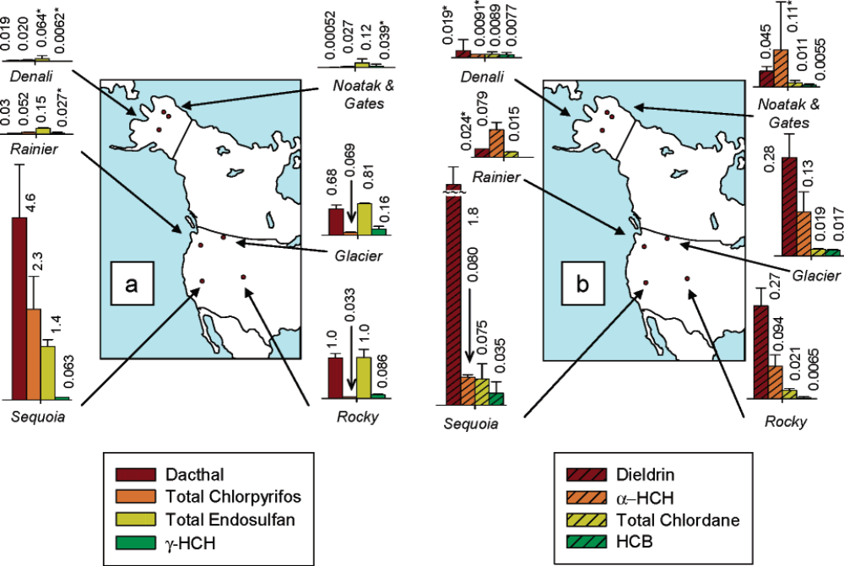
Figure 8. Figure from Hageman et al. (2006): Mean pesticide concentrations (ng·L⁻³) in seasonal snowpack samples at all sites within a given park for the four most frequently detected (a) current-use pesticides and (b) historic-use pesticides. Mean concentrations are provided above bars; note the difference in scale between (a) and (b). Error bars denote standard deviation for concentrations measured at all sites within a given park; note that error bars are not always large enough to be observed at the scale depicted here. Asterisks indicate that one or more of the concentrations used to determine the average was below the method detection limit and was, therefore, replaced by one-half of the method detection limit.
Weber et al., (2006) confirmed the presence of alpha and beta endosulfan in Artic sea water (see Figure below) and studied the air-water exchange. The fugacity ratios determined in the study indicate that alpha-endosulfan has been undergoing net deposition to surface waters across all the regions of the Arctic Ocean that were subject to seawater measurements during the 1990s. The lack of an obvious declining trend in R-endosulfan air concentrations in the high Arctic would indicate net deposition is currently prevailing.
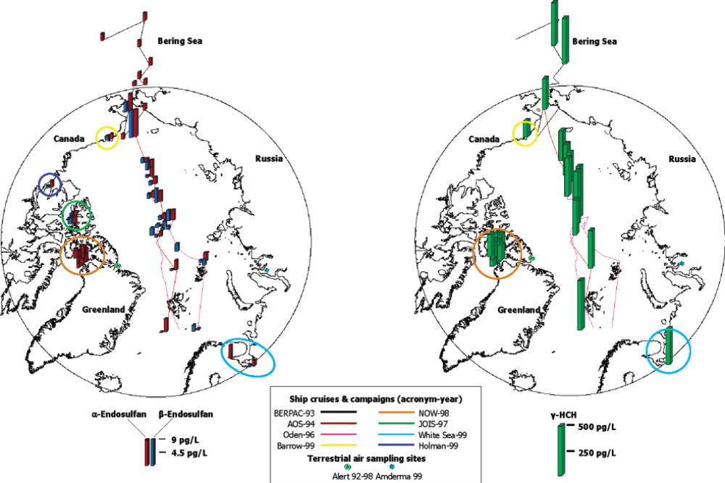
Figure 9. Figure from Weber et al 2006Error: Reference source not found: Cruise and campaign details and surface seawater concentrations of alpha-endosulfan, beta-endosulfan, and gamma-HCH in the Arctic
Carroll et al., (2008) have recently quantified in contribution from the Ob and Yenisei Rivers. These rivers, discharging into the Kara Sea, represent a 37% of the riverine freshwater inputs into the Arctic Basin. Dissolved fluxes of endosulfan discharges into the Arctic Ocean associated to the contribution of these rivers were estimated at 8 kg·y⁻¹ for alpha-endosulfan.
Sediment samples
Alpha, beta and endosulfan sulfate were not detected in marine fresh water sediment samples from 16 sampling stations distributed all over Norway (SFT, 2007).
Measurements in biota from remote locations
The European Community dossier included some references on the presence of endosulfan in biota from remote areas: Endosulfan was detected in adipose tissue and blood of polar bears from Svalbard. Mean values found for α-endosulfan were 3.8 ± 2.2 ng·g⁻¹ wet weight and 2.9 ± 0.8 ng·g⁻¹ for β-endosulfan (Gabrielsen et al. 2004). Endosulfan has also been detected in blubber of minke whale (Hobbs et al., 2003) and in liver of northern fulmar (Gabrielsen et al., 2005).
A non exhaustiv list of additional references reporting the presence of endosulfan in living organisms collected in remote areas, including the Arctic and the Antarctica, is presented below:
- Levels in murre eggs measured in 2003 at St. Lazuria Island for beta-Endosulfan ranged from 3.04 to 11.2 ng·g⁻¹ (mean 5.89 ng·g⁻¹) and for alpha-Endosulfan from 0.116 to 0.428 ng·g⁻¹ (mean 0.236 ng·g⁻¹). At Middleton Island in the Gulf of Alaska, measured levels in 2004 in murre eggs for beta-Endosulfan ranged up to 11.8 ng·g⁻¹ (mean of 6.74 ng·g⁻¹). Alpha- and beta-Endosulfan were also found in common murre eggs at East Anatuli Island, Duck Island, Gull Island, Cape Denbigh, Cape Pierce, Sledge Island, Bluff and Bogoslov Island (Roseneau et 2008)
- Endosulfan levels in Chinook and sockeye salmon, Cook Inlet Alaska ranged from 252 to 1610 ng·kg⁻¹ (USEPA, 2003)
- Within 20 years of monitoring in the Canadian Arctic, there was a 3-fold increase in age-adjusted concentrations of Endosulfan sulfate in beluga (Braune et al., 2005)
- A 3.2-fold increase of Endosulfan sulfate was observed in Cumberland Sound beluga blubber from 1982 to 2002 (Stern and Ikonomou, 2003).
- Endosulfan levels in the freshwater fish char increased 2.2 times from 1992 to 2002 (Evants et al., 2005)
- In ringed seals from Alaska, the highest levels were found in western Arctic off Barrow (geometric mean in ringed seal blubber combined males and females of 22.6 ng·g⁻¹ alpha-Endosulfan with the upper concentration at 43.39 ng g⁻¹) (Mackay and Arnold, 2005).
- Alpha-Endosulfan ranged between <0.1 and 21 ng·g⁻¹ wet weight fat, (<0.1-36 ng·g⁻¹ lipid weight) in the fat of polar bears sampled along the Alaskan Beaufort Sea coast in spring, 2003.(Bentzen et al., 2008)
- Endosulfan was found in different species in Greenland. The highest median and maximum values in ng g⁻¹ lipid weight for various tissues and locations per species are summarized here: Terrestrial species: ptarmigan (median 1.9 and max 3.0 in liver), hare (median 0.55 and max 0.64 in liver), lamb (median n.d. and max 0.65 in liver), caribou (median 0.17 and max 0.39 in muscle), muskox (median 0.016 and max 1.8 in blubber); freshwater fish, Arctic char (median 21 and max 92 in muscle tissue). Marine organisms: shrimp (median 3 and max 5.2 in muscle), snow crab (median 19 in muscle and max 95 in liver), Iceland scallop (median 0.36 and max 1.6 in muscle) capelin (median 50 ng·g⁻¹). In seabirds: common eider (median 4.9 and max 8.6 in liver), king eider (median 3.7 in liver and max 10 in muscle), kittiwake (median 62 and max 130 in muscle), thick-billed murre (median 8.8 and max 15 in liver). In marine mammals: ringed seal (median 5.6 in liver at Qeqertarsuaq and max 25 in muscle at Ittoqqortoomiit), harp seal (median 12 and max 45 in blubber), minke whale (median 12 and max 29), beluga (median 45 and max 83 in skin), and narwhal (median 81 and max 120 in skin) (Vorkamp et al., 2004)
- Alpha-Endosulfan and Endosulfan sulfate have been found in blubber of elephant seals in Antarctica. The levels found (median 3.02 and 2.68 g·kg⁻¹ lipid for adult males and females) are similar to those found in Greenland (Miranda-Filho et al., 2007).
- Alpha-Endosulfan was found in 40% of samples of Antarctic krill (Euphausia superba). The geometric mean level detected was 418 pg·g⁻¹ lw, the maximum was 451 pg·g⁻¹ lw (Bengston Nash et al., 2008.)

2.3 Releases and exposure estimations
Global usage and emission of endosulfan, and the relationship between global emissions and the air concentration of endosulfan in the Canadian arctic were reported in Li and MacDonald (2005). The major results were as follows:
Cumulative global use of endosulfan for crops is estimated to be 338 kt. The average annual endosulfan consumption in the world is estimated to be 10.5 kt from 1980 to 1989 and 12.8 kt from 1990 to 1999.
The general trend of total global endosulfan use has increased continuously since the first year this pesticide was applied. India is the world's largest consumer of endosulfan with a total use of 113 kt from 1958 to 2000.
Total global endosulfan emissions have also increased continuously since the year when this pesticide was first applied presently amounting to a total emission around 150 kt.
A time trend of alpha-endosulfan air concentration at Alert between 1987 and 1997, compiled from several sources (Patton et al., 1989, Halsall et al., 1998 and Hung et al., 2002), shows this to be one of the few OCPs that is still increasing in arctic air. The data for emissions of alpha-endosulfan show a large variance with a generally increasing trend at least up until the late 1990s. Canadian arctic air similarly exhibits scatter but the few available data are not inconsistent with the emission data, suggesting the atmosphere to be the important transporting medium.
Emission inventory of endosulfan in Canada, US and China has been constructed. Endosulfan has been extensively used in the southern US, the west coast and the Great Lake-St Lawrence valley of Canada, and central-eastern China. The Canadian Model for Environmental Transport of Organochlorine Pesticides (CanMETOP) was applied to numerical assessment of atmospheric transport to and multi-compartment fate of endosulfan in the Great Lakes for 2000 and 2001. Results indicated that the southern US and local sources adjacent to the Great Lakes made major input of the chemical to the Great Lakes. Although the usage in 2001 was almost the same as that in 2000, the modelled air concentration over the Great Lakes was notably lower in 2001 than 2000. This is consistent with the IADN measured results and is due largely to interannual climate variability.
Chinese endosulfan usage inventories were also extensively studied (Jia et al. 2008a). The major results are as follows:
The use of endosulfan in agriculture in China started on cotton in 1994, and on wheat, tea, tobacco, apple and other fruits in 1998. The annual applications of endosulfan from 1994 to 2004 in China were estimated based on the total areas of major crops on which endosulfan was applied, and spatial distribution of the application was generated at provincial and prefecture levels. Endosulfan usage on cotton, wheat, tea, tobacco, and apple in China has been estimated to be approximately 25,700 t between 1994 and 2004. The gridded endosulfan usage inventories on a 1/4° longitude by 1/6° latitude grid system were produced for China. The satisfaction of the inventories was supported by the consistence between the estimation of the annual usage and the reported annual production of endosulfan.
Based on usage inventories, historical gridded emission and residue inventories of α- and β-endosulfan in agricultural soil in China with 1/4° longitude by 1/6° latitude resolution have been created (Jia et al. 2008b). Total emissions were around 10 700 t, 7 400 t for α-endosulfan and 3 300 t for β-endosulfan from 1994 to 2004. The highest residues were 365 t for α-endosulfan and 263 t for β-endosulfan, and the lowest residues were 1.7 t for α-endosulfan and 119 t for β-endosulfan in 2004 in Chinese agricultural soil where endosulfan was applied. Based on the emission and residue inventories, concentrations of α- and β-endosulfan in agricultural surface soil and in Chinese air were also calculated for each grid cell. It turned out that the concentrations of endosulfan in Chinese soil and air derived from the endosulfan emission and residue inventories are consistent to the published monitoring data in general.
Concurrent measurements of endosulfan in Chinese air and soil across China were also carried out by the International Joint Research Center for Persistent Toxic Substances (IJRC-PTS), China, and the results are to be submitted for publication soon.

2.3.1 Environmental monitoring data
Although endosulfan has only recently been included in POP monitoring programs, the chemical is frequently measured in studies on organochlorinated pesticides, and therefore there is a large, but highly variable, database on measured levels of endosulfan in environmental samples. Most studies include alpha- and beta-endosulfan, and in some cases, endosulfan sulfate is also measured. Other endosulfan metabolites are only rarely quantified.
The information has been compiled in three main categories:
- Medium range transport: Collects the information in untreated areas located in the vicinity of areas for which endosulfan has been used or has been potentially used (areas with intensive agricultural activity).
- Potential for long range transport: Collects information in areas that although cannot be considered sufficiently remote from release sources, are located at significant distance of use areas, where the presence of endosulfan can only be explained by atmospheric transfer and deposition; include high altitude mountain areas. The information indicates the potential for atmospheric transport but does not represent a confirmation.
- Long range transport: Collects information in remote areas, far away from intensive use areas, in particular, the Arctic and the Antarctica.
A summary of a set of relevant monitoring values is presented below. This summary is mostly based in the recent reviews by the European Communities and the USA submitted within their information dossiers, and completed by additional information presented by other parties/observed and the review of recent literature data.
Medium range transport: water and aquatic organisms
Since 1991, the South Florida Water Management District’s (SFWMD) non-target quarterly water quality monitoring program has been analyzing a number of pesticides including endosulfan at 34 sites. Endosulfan and endosulfan sulfate were detected in surface waters and benthic sediments at several locations in the south Miami-Dade County farming area. Endosulfan has been measured at concentrations exceeding the US chronic surface water quality standard of 0.056 μg L⁻¹ (see figure below) for a number of years (assuming endosulfan sulfate has similar toxicity to parent endosulfan).
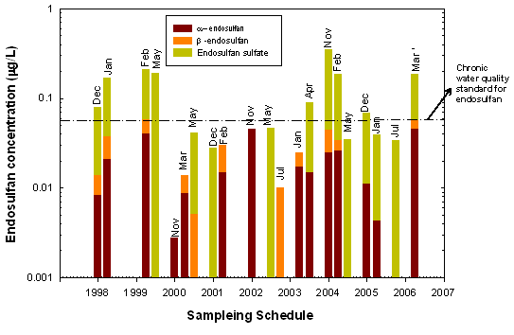
Figure 10. Concentrations of parent and endosulfan sulfate in surface water samples from site S178, South Florida
In 1997, pesticide concentrations were measured in mountain yellow-legged frogs (Rana muscosa) from two areas in the Sierra Nevada Mountains of California, USA. One area (Sixty Lakes Basin, Kings Canyon National Park) had large, apparently healthy populations of frogs. A second area (Tablelands, Sequoia National Park) once had large populations, but the species had been extirpated from this area by the early 1980s. The Tablelands is exposed directly to prevailing winds from agricultural regions to the west. When an experimental reintroduction of R. muscosa in 1994 to 1995 was deemed unsuccessful in 1997, the last 20 (reintroduced) frogs that could be found were collected from the Tablelands, and pesticide concentrations in both frog tissue and the water were measured at both the Tablelands and at reference sites at Sixty Lakes. The two endosulfan isomers and the sulfate degradation product of endosulfan are registered for use by United States farmers and are applied in the Central Valley agricultural region of California. After the chemical analysis residues of both endosulfan isomers and the sulfate degradation products were present in water from both Tablelands and Sixty Lakes. The reported range for α- and β-isomers from the Tablelands and Sixty Lakes are 0.3-1 ng·l⁻¹ and 0.17-1.8 ng·l⁻¹ respectively. Endosulfan sulfate concentrations were almost an order of magnitude higher at the Tablelands (2.2-2.9 ng·l⁻¹) compared with Sixty Lakes (0.3-0.34 ng·l⁻¹). In tissue samples, only the α-endosulfan isomer was observed at levels above quantification limits and concentrations at the Tablelands sites were not significantly different from the Sixty Lakes sites (p = 0.30). The authors considered that these results support the hypothesis that contaminants have played a significant role in the decline of R. muscosa in the Tablelands of Sequoia National Park (LeNoir et al., 1999).
The University of South Carolina (USC) and the National Oceanic and Atmospheric Administration (NOAA) also conducted a monitoring study targeting areas where endosulfan was used (Delorenzo et al., 2001). These data suggest that in the vicinity of row crops where endosulfan is reportedly applied, endosulfan residues have been routinely detected in both the water column and benthic sediments. Additionally, the data indicate that total endosulfan residues have moved to areas distant from where it was initially applied and that the residues are sufficiently high, when compared to toxicity values of aquatic organisms to exceed the Office of Pesticide Programs’ (OPP) acute and chronic risk levels of concern.
Results of the field studies conducted during 2002 -2004 by Harman-Fetcho et al. (2005) and 1993 -1997 by Scott et al. (2002) also indicate the presence of endosulfan in surface water samples from southern Florida and Florida Bay. In a two year study, endosulfan was frequently detected in the South Florida canals and Biscayne Bay, with an average concentration of 11 ng·L⁻¹ (Harman-Fetcho et al., 2005Error: Reference source not found). Endosulfan concentrations were higher near vegetable production areas where endosulfan is applied.
California Department of Pesticide Regulation, Environmental Hazard Assessment Program (EHAP), United States Geological Survey (USGS), and the Central Valley Regional Water Quality Control Board carried out pesticide monitoring studies for surface water (CDPR 2000). Data from these and other studies are documented in EHAP’s surface water database (SURF). Endosulfan sulfate had the highest detection frequency at 17.2% and the 95th percentile concentration was 0.14 μg·L⁻¹ compared to the detection frequencies of 5.2% to 5.4% and the 95th concentrations of 0.11 and 0.07 μg·L⁻¹ for parent endosulfan and β-endosulfan, respectively.
Water samples from four temperate lakes in south-central Canada show the presence of α-and β-endosulfan (Muir et al., 2004). Mean concentration levels of α-endosulfan ranged from 1.3 to 28.5 pg·L⁻¹, and those of β-endosulfan from 0.0 to 10.3 pg·L⁻¹ in lakes Opeongo, Nipigon, Britt Brook, and Virgin pond. No agricultural area was within 31 miles (50 Km) of any of these lakes, suggesting that the presence of endosulfan resulted from atmospheric transportation and deposition. Monitoring and modeling results suggest that under the conditions prevailing in south-central Canada, endosulfan can potentially undergo regional-scale atmospheric transport and reach lakes outside endosulfan use areas.
Monitoring data for endosulfan shows the presence of endosulfan in waters of isolated lakes in Ontario and New Brunswick (UNEP, 2002). Endosulfan, was detected in all lake trout collected from these isolated lakes; endosulfan tissue residues ranged from <0.1-0.8 ng·g⁻¹ ww. Endosulfan was higher in Labrador lakes. The results suggest the wide dispersal of endosulfan from areas of use to isolated lakes.
Medium range transport: Air and airborne particles
Detailed atmospheric concentrations of α-endosulfan and β-endosulfan were summarized by Ngabe and Bidleman (2001) in North America. Early measurements of endosulfan in air were made during a survey of airborne pesticides across the United States in 1970 (Majewski and Capel, 1995). Mean concentrations of α-endosulfan ranged from 0.7 ng·m⁻³ in Meadow, North Carolina, to 159 ng·m⁻³ in Peaksmill, Kentucky. The average concentrations of α- and β-endosulfan in air were 0.170 and 0.045 ng·m⁻³ at Solomons, Maryland, in 1995 (Harman-Fetcho et al., 2000). The frequency of occurrence of α- and β-endosulfan in monitoring samples was 100%.
Air Resource Board (ARB) of California monitored an endosulfan application to an apple orchard in San Joaquin County in April 1997, and conducted ambient air monitoring during a period of high use of endosulfan in Fresno County in July-August 1996 (Cited in USEPA, 2007). Air concentrations of α-endosulfan ranged from 3800 ng·m⁻³ and 290 ng·m⁻³. The detections for β-endosulfan during the same sampling period ranged from 200 ng·m⁻³ to 48 ng·m⁻³. The ratio of α-isomer: β-isomer varied from 5 to 209 across all the samples with concentrations of both isomers above the limit of quantification (LOQ).
Some monitoring in California for endosulfan coincided with expected applications to grapes and cotton. The maximum concentrations in ambient air were 140 ng·m⁻³ for α-endosulfan and 26 ng·m⁻³ for β-endosulfan. The highest average concentrations for various sites were 24 ng·m⁻³ for α-endosulfan and 5.4 ng·m⁻³ for β-endosulfan. All the highest concentrations occurred at one site in the town of San Joaquin, CA, which is three quarters to one mile from the closest endosulfan use area.
Abundant regional concentration data are available for the Great Lakes Region from a joint US EPA / Environment Canada-monitoring project IADN (Integrated Atmospheric Deposition Network) (Sun et al., 2006) and Sun et al. (2003) providing compelling evidence for medium-range airborne transport of endosulfan and endosulfan sulfate. The endosulfan concentrations (shown as the sum of α- and β-endosulfan) in vapor phase showed a clear increasing trend from the west to east, except for the remote site of Burnt Island. At each site, the average concentration was skewed by high outliers that usually occurred in the summer and were attributed to current agricultural use of endosulfan. Higher endosulfan concentrations were observed at Point Petre, Sturgeon Point, and Sleeping Bear in vapor, particle, and precipitation phases, which could be explained by its heavy usage in the surrounding areas (Hoh and Hites, 2004). For example, endosulfan is widely used in Michigan and New York State (Hafner and Hites, 2003) and in Ontario (Harris, et al., 2001), particularly in the southern and western portions of the province.
Total endosulfan concentrations showed no long-term decreasing trends in the vapor phase at Eagle Harbor (EH), Sleeping Bear Dunes (SBD), or Sturgeon Point (SP) (see Figure below). However, total endosulfan concentrations in the particle phase declined at all five U.S. sites. In the precipitation phase, total endosulfan concentrations only decreased at Point Petre (PP), while at the other six sites, these concentrations did not change from 1997 to 2003. The National Center for Food and Agriculture Policy provides an endosulfan usage database for the period 1992-97 in the U.S. Although endosulfan usage in Michigan significantly decreased from 29 tons to 19 tons between 1992 and 1997, increasing usage was also observed in the surrounding states, including New York, Indiana, Kentucky, and Minnesota. Because of the lack of updated usage data, correlation between the decreasing particle-bound endosulfan concentrations and its usage pattern is difficult.
Total endosulfan concentrations also showed a strong seasonal variation in precipitation. The ratio between the highest and the lowest total endosulfan concentration ranged between about 2-10. In particular, this ratio is as high as 10 at Point Petre, suggesting a heavy usage in the surrounding area. At all sites, the total endosulfan concentrations peaked in early July in precipitation, a time which corresponds well with its maximum agricultural usage.
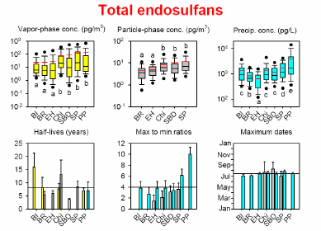
Figure 11. Spatial and temporal trends of total endosulfans (sum of α- and β-endosulfan) (USEPA, 2007)
Shen et al. (2005) evaluated endosulfan concentration in air using passive air samplers (PAS) to trap endosulfan. Gaseous concentrations of endosulfan varied from 3.1 to 681 pg·m⁻³ for α-endosulfan and from 0.03 to119 pg·m⁻³ of β-endosulfan. The maximum measured concentration of endosulfan in air was generally lower than 58 pg·m⁻³ across North America. The highest measured concentrations were reported in the Okanagan Valley, British Columbia, East Point on Prince Edward Island, Manitoba, and Tapachula, Mexico
Within the IADN project, endosulfan concentrations were also measured in airborne particulate (filter-retained) matter. Average concentration levels were approximately 7.5 pg·m⁻³ for α-endosulfan and 2.9 pg·m⁻³ for β-endosulfan from 1995 to 2000. Seasonal differences for particles were much less pronounced as compared with the gas-phase data. Endosulfan associated with airborne dust was also measured on a cotton farm in Australia during the growing season. Total endosulfan residues (α- + β- + -sulfate) in airborne dust ranged from 0.07 to 1.04 μg·g⁻¹ (Leys et al., 1998).
Medium range transport: Rainwater and snow
Several studies demonstrated that endosulfan is removed from the atmosphere by rain and snow fall. In a monitoring study carried out in eastern Canada between 1980 and 1989, α-endosulfan was reported occasionally at concentrations near the detection limit of 10 ng·L⁻¹ (Brun et al. (1991). In precipitation of the Great Lakes region, α- and β-endosulfan concentrations were regularly determined by the Integrated Atmospheric Deposition Network (IADN) at various stations during the period of 1987–1997. Concentration levels of α-endosulfan ranged from 0.13 – 1.95 ng·L⁻¹ and those of β-endosulfan from 0.19 – 6.09 ng·L⁻¹ in Lake Superior and Lake Erie. Higher values were reported from Lake Michigan ranging from 0.54 – 8.22 ng·L⁻¹ for α-endosulfan and from 1.06 – 12.13 ng·L⁻¹ for β-endosulfan. Unlike for vapor- phase concentrations, it has been observed that the β-isomer was often higher in precipitation than the α-isomer. This equal or greater observed wet deposition of β-endosulfan compared to α-endosulfan might be explained by the comparatively higher importance of particle vs. gas-phase scavenging. Concentrations of the transformation product endosulfan sulfate measured in precipitation of the Great Lakes region were mostly in a range of 0.1 to 1 ng·L⁻¹.
Endosulfan and endosulfan sulfate were detected in seasonal snowpack samples at six national parks in the Western United States (Hageman et al., 2006). Concentrations of total endosulfan concentrations were 1.5 ng·L⁻¹ to 0.0040 ng·L⁻¹ in the Sequoia, Mount Rainier, Denali, Noatak-Gates, Glacier and Rocky Mountain National Parks. The percentage contribution of endosulfan sulfate to the total endosulfan concentration ranged from 4.0% to 57.0% with mean value being 24.0%. The study results suggest that current use of endosulfan plays a significant role in contributing to the deposition of endosulfan via snow to remote high-elevation and high-latitude ecosystems.
Medium range transport: Sediment
The presence of endosulfan in the sediments is well documented in the National Sediment Contaminant Point Source Inventory (NSI) databases prepared by the Office of Science and Technology (OST) of US EPA (EPA-823-C-01-001) (Cited in USEPA, 2007). EPA’s evaluation of the NSI data was the most geographically extensive investigation of sediment contamination ever performed in the United States. In the NSI data base, 199 detections for α-endosulfan, ranged from 0 to 11000 μg·Kg⁻¹; 667 detections for β-endosulfan, ranged 0 to 67500 μg·Kg⁻¹, and 195 detections for endosulfan sulfate ranged from 0.2 to 900 μg·Kg⁻¹ (after eliminating uncertain data, e.g. ND and data presented as “less than” values ) in the sediments were reported between 1980 and 1999.
Seventy sediment samples were collected over a 10-county area in the agriculture-dominated Central Valley of California, with most sampling sites located in irrigation canals and small creeks, to investigate the distribution of 26 pesticides including endosulfan (Weston et al., 2004). Total endosulfan concentrations in sediments ranged from 571 µg·Kg⁻¹ to <1.0 µg·Kg⁻¹. They also investigated the sediment toxicity of endosulfan. Measured 10-day LC₅₀ values for C. tentans were 0.96, 3.24, and 5.22 mg·Kg⁻¹ of organic carbon (oc) for α -, β -, and endosulfan sulfate respectively. Measured 10-day LC₅₀ values for H. azteca were 51.7, >1000, and 873 mg·Kg⁻¹ of organic carbon for α-, β-, and endosulfan sulfate, respectively. Endosulfan concentrations were below the acute toxicity of aquatic invertebrates in the majority of samples; however, the study suggests that endosulfan may have contributed to toxicity in the tailwater ponds or a few irrigation canals where concentrations exceeded several hundred µg·Kg⁻¹. Endosulfan residues have been detected in several sites in south Florida. The concentrations of endosulfan in sediment samples ranged from 100 µg·Kg⁻¹ to non-detect.
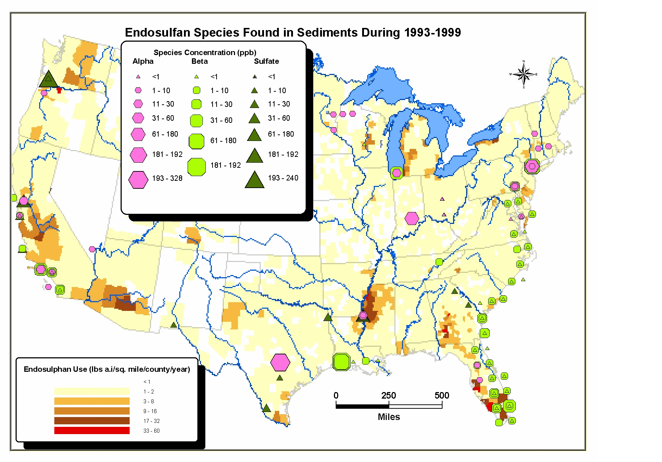
Figure 12. Spatial distribution of endosulfan in sediments (USEPA, 2007)
Potential for Long-Range transport: Mountainous Regions
The effect of "global distillation" which is believed to account for transport of persistent organic pollutants (POPs) whereby a compound could volatilize from warmer regions, undergo long-range atmospheric transport and subsequently recondense to an accumulation of these substances in the temperate, higher mountainous and Arctic regions. Wania and Mackay (1993) suggested that, through “global distillation” of organic compounds could become latitudinally fractionated, “condensing” at different temperatures according to their volatility, so that compounds with vapor pressures in a certain low range might accumulate preferentially in polar regions. Endosulfan was found in the atmosphere of European mountain areas (Central Pyrennes and High Tatras). Like hexachlorocyclohexane (HCH), endosulfan was found in higher concentrations in the warm periods (4-10 pg·m⁻³) in the gas phase and particulate phase, reflecting their seasonal use pattern (Drooge and Grimalt 2004). Many POP substances as well as endosulfan were found in snowpack samples collected at different altitudes of mountains in western Canadian (Blais et al., 1998). The levels of contaminants in snow and in snowpack increased with the altitude. The concentration range of α-endosulfan was 0.06–0.5 ng·L⁻¹ in the sampling altitude range of 700 – 3,100 m. Aerial transport also caused contamination of snow (Sequoia National Park) and water (Lake Tahoe basin) of the Sierra Nevada Mountains in California, a region adjacent to the Central Valley which is among the heaviest pesticide use areas in the U.S.. Levels of α-endosulfan found in rain were in a range of < 0.0035 ng·L⁻¹ to 6.5 ng·L⁻¹ while β-endosulfan was determined at concentrations of < 0.012 ng·L⁻¹ up to 1.4 ng·L⁻¹ McConnell et al. (1998).
For mountain lakes in the Alpes, Pyrenees (Estany Redò and Caledonian Mountains (Øvre Neådalsvatn (Norway), via atmospheric deposition of endosulfan was estimated between 0.2 and 340 ng·m⁻² per month (Carrera et al., 2002). Unlike for other chemicals, endosulfan showed a more uniform geographical distribution, the lakes in the South were much more exposed to endosulfan impact, reflecting the impact of agricultural activities in southern Europe. In the northern lake only the more recalcitrant endosulfan sulfate was determined.
Long-Range transport: Arctic Areas
The US review (USEPA, 2007) summarizes information by GFEA (2007); Ngabe and Bidleman 2001, and Endosulfan Task Force (ETF) report MRID 467343-01.
Long range atmospheric transport of α- and β-endosulfan to the Arctic was first noticed in 1986–1987 (Patton et al. 1989). A “brown snow” event occurred in the central Canadian Arctic during the year 1988. The snow was colored by dust that appeared to be transported from western China. Endosulfan was detected in the dust at a concentration of 22 pg·L⁻¹. Since then endosulfan has been routinely found in the Canadian Arctic air monitoring program, from 1993 up to the present (Halsall et al., 1998; Hung et al., 2001). Extensive monitoring data of endosulfan from the Arctic are available for the atmosphere, snowpack, surface water and biota (Bidleman et al., 1992; De Wit et al., 2002; Halsall et al., 1998; Hobbs et al, 2003Error: Reference source not found; Jantunen and Bidleman, 1998).
Long-Range transport: Arctic Air
Endosulfan was reported as a widely distributed pesticide in the atmosphere of Northern polar regions. Unlike for most other organochlorine pesticides, which have fallen, average concentrations of endosulfan in the Arctic have not changed significantly during the last five years (Meaking, 2000). Concentrations of endosulfan (isomers unspecified) from Arctic air monitoring stations increased from early to mid-1993and remained at that level through the end of 1997 at 0.0042-0.0047 ng/m3. No clear temporal trends of endosulfan concentrations are found in the arctic atmosphere (Hung et al., 2002). Measurements taken in air at Alert, Nunavut, Canada resulted in annual average concentrations between 3 and 6 pg·m⁻³ during 1993 to 1997. Fluctuating values mirror the seasonal applications in source regions.
Concentrations of endosulfan in Arctic air were found to be exceeded only by those of ΣHCH-isomers and HCB (Halsall et al., 1998). In comparison to monitored concentrations in the Great Lakes region, atmospheric levels in the Artic were less dependent on temperature, although seasonal variations were apparent as well. For example α-endosulfan concentrations ranged a factor of 3-5 over spring to fall periods. This infers a more blurred bimodal seasonal cycle with growing distance from areas of application. Hung et al. (2002) used temperature normalization, multiple linear regression, and digital filtration to analyze the temporal trends of an atmospheric dataset on organochlorine pesticides (OCs) collected at the Canadian high arctic site of Alert, Nunavut. While air concentrations of Lindane and Chlordane showed decreasing trends through the 1990s with half-lives of 5.6 and 4.8 years α- endosulfan showed a very slow decline with a half-live of 21 years.
Seasonal variation of concentrations was also reported from Sable Island (240 km east of Nova Scotia at 43°57´N, 60°00´W). In summer aerial endosulfan concentration (α- and β-isomer) were determined between 69 and 159 ng·m⁻³ while for wintertime values dropped to 1.4-3.0 pg·m⁻³ (only α –isomer) (Bildemar et al., 1992).
Similar data on α-endosulfan have been reported from Resolute Bay (Cornwallis Island, 75 N lat.) where air concentrations of approximately 4 pg·m⁻³ have been measured (Bidleman et al., 1995) and from air samples taken on an iceberg that calved off the Ward Hunt Ice Shelf on the northern shore of Ellesmere Island (approx. 81°N, 100°W). Mean concentration of α-endosulfan in summer 1986 and 1987 were 7.1 and 3.4 ng·m⁻³, respectively (Patton et al., 1989). Additional evidence for airborne long-range transport is provided by data from New Foundland showing mean concentrations of 20 pg/m³ in summer 1977(Bidleman et al., 1981).
Further air concentrations of endosulfan were reported from Amerma (eastern Arctic part of Russia) between 1–10 pg·m⁻³ (De Wit et al., 2002; Konoplev et al., 2002). Endosulfan was detected in around 90% of all samples displaying a significant correlation with atmospheric temperature. Unlike for other organochlorines with seasonal enhancements being suggested to be due to (re)volatilization from secondary sources, fresh applications were assumed to be responsible for endosulfan concentrations of 3.6 pg·m⁻³ in winter and 5.8 pg·m⁻³ in summer (mean values). Spatially, the annual concentrations at the various circumpolar sites did not show remarkable differences, indicating a degree of uniformity in contamination of the Arctic atmosphere.
Long-Range transport: Arctic Freshwater
Endosulfan (isomer unspecified) was measured also at Amituk Lake (75° 02´ 57´´N, 93° 45´51´´W) on Cornwallis Island, NV, Canada. The ranges were (in ng·L⁻¹) 0,135 – 0.466 in 1992, 0.095 – 0.734 in 1993, and 0.217 – 0.605 in 1994 (quoted in Ngabè and Bidleman 2001). Annual summertime peaks in endosulfan concentrations observed were attributed to fresh input from snow smelt via influent streams.
Long-Range transport: Arctic Freshwater Sediment
Laminated cores collected from Arctic Lake DV09 on Devon Island in May 1999 were analysed inter alia for endosulfan. Only α-endosulfan was present in the sediment of that lake. The concentration was highest at the sediment surface, and rapidly decreased to below detection limits in core slices dated prior to 1988 (USEPA, 2007)
Long-Range transport: Arctic Seawater
Endosulfan was measured repeatedly in Arctic seawater during the 1990s. Mean concentrations were similar to those of chlordane and ranged from 2-10 pg·L⁻¹. Seasonal trends displayed increasing concentrations during the open water season suggesting fresh input from gas exchange and runoff. This trend parallels seasonal trends observed in Arctic air and Amituk Lake.
A survey of several pesticides in air, ice, fog, sea water and surface micro-layer in the Bering and Chuckchi Seas in summer of 1993 (Chernyak et al., 1996) identified α-endosulfan in air and subsurface seawater at levels around 2 pg·L⁻¹. In melted ice less than 9 pg·L⁻¹and for the sea water surface micro-layer less than 40 pg·L⁻¹were detected. For fog condensates from several sites of that region concentration of <10 to <0.5 ng·L⁻¹were reported. β-endosulfan was found in several atmospheric samples, e.g. from the Central Bering or Gulf of Anadyr at concentrations around 1 pg·m⁻³. Similar concentrations of endosulfan have been reported from seawater samples from surface layer (40-60 m) collected in the Bering and Vhukchi Sea, north of Spitzbergen and the Greenland Sea (Jantunen and Bidleman, 1998).
Arctic seawater concentrations of, endosulfan and lindane were collected from 1990s to 2000 for different regions of the Arctic Ocean (Weber et al., 2006). Surface seawater concentrations for α- and β-endosulfan ranged from <0.1 to 8.8 pg·L⁻¹ and 0.1 to 7.8 pg·L⁻¹ respectively. Geographical distribution for α-endosulfan revealed that the highest concentrations in the western Arctic, specifically in Bering and Chukchi Seas with lowest levels towards the central Arctic Ocean. The results of air-water fugacity ratio indicate that α-endosulfan has been undergoing net deposition to surface waters across all the regions of the Arctic Ocean since 1990s. The authors concluded that the net deposition through air-water transfer may be the dominant pathway into the Arctic Ocean for α-endosulfan, particularly during the ice free periods.
Long-Range transport: Arctic Snow and Snowpack
Endosulfan concentrations of α-endosulfan in snow samples collected in the Agassiz Ice Cap, Ellesmere Island, Canada in 1986 and 1987 were determined with a concentration range of 0.10 – 1.34 ng·m⁻³ (Gregor and Gummer, 1989). The concentrations of α- endosulfan in snowpack in Agassiz Ice Cap were 0.288 ng·L⁻¹ in 1989 and 0.046 ng·L⁻¹ in 1992 (Franz et al., 1997). From measured snowpack concentrations and snowfall amounts winter deposition rates of 0.03 μg/m2 at minimum were estimated for the years 1986 and 1987 (Barrie et al., 1992).
Long-Range transport: Arctic Biota
Alpha-Endosulfan was found in 40% of samples of Antarctic krill (Euphausia superba). The geometric mean level detected was 418 pg/g lipid weight (lw), the maximum was 451 pg·g⁻¹ lw (Bengston et al., 2008).
Endosulfan was found in different species in Greenland. The highest median and maximum concentrations in n·g⁻¹ lw for various tissues and locations per species are summarized here: Terrestrial species: ptarmigan (median 1.9 and max 3.0 in liver), hare (median 0.55 and max 0.64 in liver), lamb (median n.d. and max 0.65 in liver), caribou (median 0.17 and max 0.39 in muscle), muskox (median 0.016 and max 1.8 in blubber); freshwater fish, Arctic char (median 21 and max 92 in muscle tissue). Marine organisms: shrimp (median 3 and max 5.2 in muscle), snow crab (median 19 in muscle and max 95 in liver), Iceland scallop (median 0.36 and max 1.6 in muscle) capelin (median 50 ng·g⁻¹). In seabirds: common eider (median 4.9 and max 8.6 in liver), king eider (median 3.7 in liver and max 10 in muscle), kittiwake (median 62 and max 130 in muscle), thick-billed murre (median 8.8 and max 15 in liver). In marine mammals: ringed seal (median 5.6 in liver at Qeqertarsuaq and max 25 in muscle at Ittoqqortoomiit), harp seal (median 12 and max 45 in blubber), minke whale (median 12 and max 29), beluga (median 45 and max 83 in skin), and narwhal (median 81 and max 120 in skin) (Vorkamp et al., 2004).
Blubber samples from male beluga (Delphinapterus leucas), were collected over 20 years at five time points in Cumberland Sound, Canada; only endosulfan sulfate was detected. But unlike other organochlorines levels appear to have increased steadily (3.2 fold) over that 20 year time period from 1982 reaching ca. 14 ng·g⁻¹ lipid wt in 2002. α-endosulfan concentrations in blubber of minke whale (Balaenoptera acutorostrata) populations from distinct parts of the North Atlantic were sampled in 1998 (Hobbs et al., 2003). The highest mean concentrations were found for whales in the North Sea/Shetland Islands (34 ng·g⁻¹ lipid for females and 43.0 ng/g⁻¹ for males), the Barents Sea (7.74 ng·g lipid for females and 9.99 ng·g⁻¹ for males) and Vestfjorden/ Lofotes (4.51 ng·g⁻¹ lipid for females and 9.17 ng·g lipid for males). Lower concentrations of < 1 ng·g⁻¹ and 5 ng·g⁻¹ lipid were reported for whales from Jan Mayen and Greenland. The differences were attributed to distinctions based on genetics, fatty acid profiles, etc.
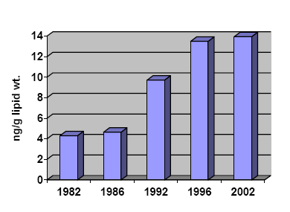
Figure 13. Temporal trends of age-adjusted concentrations of endosulfan in blubber of male beluga from Pangnirtung, Nunavut, Canada (USEPA, 2007)
Endosulfan was detected in adipose tissue and blood of polar bears from Svalbard. Mean values found for α-endosulfan were 3.8 ± 2.2 ng·g⁻¹ wet weight (min-max: 1.3-7.8 ng·kg⁻¹) and 2.9 ± 0.8 ng·g⁻¹ for β-endosulfan (min-max: 2.2-4.3 ng·g⁻¹). While the α-isomer was detectable in all samples (15/15) the β-isomer was found in just 5 out of 15 samples.
Alpha-Endosulfan ranged between <0.1 and 21 ng·g⁻¹ wet weight fat, (<0.1-36 ng·g⁻¹ lipid weight) in the fat of polar bears sampled along the Alaskan Beaufort Sea coast in spring, 2003 (Bentzen et al., 2008).
In liver of northern fulmar (Fulmarus glacialis) from Bjørnøja endosulfans were detected for just two individuals out of fifteen at low levels of 0.28 and 0.50 ng·kg⁻¹ lipid weight (Gabrielsen, 2005).
Levels in murre eggs measured in 2003 at St. Lazuria Island for beta-Endosulfan ranged from 3.04 to 11.2 ng·g⁻¹ (mean 5.89 ng·g⁻¹) and for alpha-Endosulfan from 0.116 to 0.428 ng·g⁻¹ (mean 0.236 ng·g⁻¹). At Middleton Island in the Gulf of Alaska, measured levels in 2004 in murre eggs for beta-Endosulfan ranged up to 11.8 ng·g⁻¹ (mean of 6.74 ng·g⁻¹). Alpha- and beta-Endosulfan were also found in common murre eggs at East Anatuli Island, Duck Island, Gull Island, Cape Denbigh, Cape Pierce, Sledge Island, Bluff and Bogoslov Island in Alaska (Roseneau et al., 2008).
Endosulfan levels in Chinook and sockeye salmon, Cook Inlet Alaska ranged from 252 to 1610 ng·kg⁻¹ (USEPA, 2003).
In ringed seals from Alaska, the highest levels were found in western Arctic off Barrow (geometric mean in ringed seal blubber combined males and females of 22.6 ng·g⁻¹ alpha-Endosulfan with the upper concentration at 43.39 ng·g⁻¹) (Mackay and Arnold, 2005).

2.4. Hazard assessment
Endosulfan is highly toxic for most invertebrates and vertebrates, including humans. The insecticidal properties are shared, with some differences in potency, by the alpha and beta isomers and the metabolite endosulfan sulfate.
The toxicity of endosulfan has been evaluated by several organizations, including among others JMPR in 1998 (FAO/WHO, 1998); ATSDR in 2000 (ATSDR, 2000); the EU in 1999 with addenda up to 2004 (EC dossier submitted as additional information, INIA 1999-2004); an EFSA Scientific Panel in 2005 (EFSA, 2005), Australia in 2005 (submitted as additional information), Canada in 2007 (PMRA’s REV2007, submitted as additional information), US EPA in 2007 (submitted as additional information), and New Zealand in 2008 (submitted as additional information).
The toxicity of other endosulfan metabolites has also been demonstrated for different species including humans.

2.4.1 Adverse effects on aquatic organisms
Endosulfan alpha, beta and sulfate are highly toxic to aquatic invertebrates and fish. Acute LC_{50s} for several species at levels below 1 µg·l⁻¹ have been reported. Chronic NOECs below 0.1µg·l⁻¹ have been reported for fish and aquatic invertebrates. Likewise, endosulfan is extremely toxic to some larval amphibians. Relyea (2008) found that leopard frog tadpoles (Rana Pipiens) exposed to 6.4 µg·l⁻¹ aqueous endosulfan experienced 84% mortality. In contrast grey tree frog tadpoles (Hyla versicolor) were unaffected by exposure to this level of endosulfan alone or in combination with other insecticides, and survival to metamorphosis was statistically identical to controls. LC50s as low 1 µg·l⁻¹ have been found for some tadpole species, and Litoria Citropa tadpoles exposed to 0.8 µg·l⁻¹ experienced 11–34% mortality. Shenoy (2009) observed 100% mortality for R. pipiens exposed to 1 µg·l⁻¹ endosulfan 28 days. Exposure to 0.2 µg·l⁻¹ also resulted in significant mortality (a relative risk of death of 4.66 for a 7 week exposure.)
A significant toxicity for aquatic organisms has been also observed for other metabolites, the acute LC_{50s} for endosulfan lactone and ether are lower than 1 mg·l⁻¹ (highly toxic to aquatic organisms according to the UN-GHS classification), and for endosulfan hydroxyether is within the 1-10 mg·l⁻¹ range (toxic to aquatic organisms according to the UN-GHS classification).
The NOEC for sediment dwelling organisms tend to be between 0.1 and 1 mg·kg⁻¹ with equivalent pore water concentration of about 1 µg·l⁻¹.
The dietary toxicity of endosulfan on fish has been studied in Atlantic salmon (Salmo salar), histopathological effects were observed after 35 d of exposure at a diet containing 4 µg·kg⁻¹ of endosulfan, and the condition factor was significantly reduced in fish exposed for 49 d to 500 µg·kg⁻¹ (Petri et al., 2006; Glover et al., 2007).
Additional sublethal effects of particular concern, including genotoxicity and endocrine disrupting effects have been reported. Associated genotoxic and embriotoxic effects have been observed in oisters exposed to endosulfan (Wessel et al., 2007). Endosulfan sulfate has been shown to be an anti-ecdysteroidal compound for Daphnia magna delaying the molting process (Palma et al., 2009). The ecdysteroid system is used by crustaceans and other arthropods as the major endocrine signalling molecules, regulating processes such as molting and embryonic development. Neurotoxicity has been observed in common toad (Bufo bufo) tadpoles (Brunelli et al., 2009), and developmental abnormalities on anuran Bombina orientalis embryos (Kang et al., 2008). In ovum exposure at a critical period for gonadal organogenesis provoked post-hatching effects in Caiman latirostris (Stoker et al., 2008).
Immunotoxicity has been observed in Nile tilapia (Tellez-Bañuelos et al., 2008; Girón-Pérez et al., 2008).
Toxic effects have also been observed on non-animal species, including cyanobacteria (Kumar et al., 2008) and aquatic macrophytes (Menone et al., 2008).

2.4.2 Adverse effects on terrestrial organisms
In laboratory animals, endosulfan produces neurotoxicity effects, which are believed to result from over-stimulation of the central nervous system. It can also cause haematological effects and nephrotoxicity. The α-isomer was generally found more toxic than the β-isomer (ATSDR, 2000).
The lowest relevant NOEC for Endosulfan in terrestrial vertebrates is 0.6 mg·kg⁻¹ bw·day⁻¹ based on reduced body-weight gain, increased marked progressive glomerulonephritis, blood vessel aneurysm in male rats at 2.9 mg·kg⁻¹ bw·day⁻¹; the same value was reported in a 1-year dog study.
Reproductive effects on Mallard duck where observed at low dietary levels; the reported NOEC was 30 ppm in the diet. The acute LD₅₀ value in this species is of 28 mg·kg⁻¹ bw.
Toxicity has been shown for bees and soil dwelling invertebrates in the laboratory and field studies (i.e., New Zealand dossier, Vig et al., 2006).

2.4.3 Adverse effects on human health
Endosulfan is highly acutely toxic via the oral, dermal and inhalation routes.
Excessive or improper application and handling of endosulfan have been linked to congenital physical disorders, mental retardations and deaths in farm workers and villagers in developing countries in Africa, southern Asia and Latin America. A survey conducted by PAN Africa in Mali in 2001 villages in 21 areas Kita, Fana and Koutiala found 73 cases of pesticide poisoning and endosulfan were the main pesticide in question. Endosulfan was found among the most frequently reported intoxication incidents, adding unintentionally further evidence to its high toxicity for humans.
The primary effect of endosulfan, via oral and dermal routes, is on the central nervous system (CNS). Effects in laboratory animals as a result of acute, subchronic, developmental toxicity and chronic toxicity studies indicate that endosulfan causes neurotoxic effects, particularly convulsions, which may result from over stimulation of the CNS. Possible mechanisms of neurotoxicity include (a) alteration of neurotransmitter levels in brain areas by affecting synthesis, degradation, and/or rates of release and reuptake, and/or (b) interference with the binding of neurotransmitter to their receptors. Additional effects were noted in the liver, kidney, blood vessels and hematological parameters following repeated exposure to endosulfan.
Acute exposure to high doses of endosulfan results in hyperactivity, muscle tremors, ataxia, and convulsions. The LD50 of endosulfan varies widely depending on the route of administration, species, vehicle, and sex of the animal. Female rats are clearly more sensitive than male rats, and, on the basis of a single study, this sex difference appears to apply to mice also. The lowest oral LD50 value is 9.6 mg·kg⁻¹ b.w. in female Sprague-Dawley rats. The lowest dermal LD50 value is 106 mg·kg⁻¹ bw in rabbits and the low inhalational LC50 is 0.0126 mg L⁻¹ (2.13 mg kg⁻¹ bw ) in female rats. Endosulfan is a slight eye and skin irritant in rabbits but not a skin sensitiser to guinea pigs.
The lowest oral LD50 value is 9.6 mg·kg⁻¹ b.w. in female Sprague-Dawley rats. The lowest relevant NOAEL for Endosulfan in laboratory animals is 0.6 mg·kg⁻¹ bw·day⁻¹, based on a 1-year dietary study in dogs, a 2-year dietary study in rats, and a developmental study in rats. Major toxicological endpoints include decreases body weight gains, increases in kidneys and liver weight with pathological changes. In chronic studies in mice and rats, no treatment related neoplastic lesions or an increase in the incidence of neoplastic lesions were seen. Endosulfan was tested negative in a battery of in vitro and in vivo genotoxicity studies and did not show specific reproductive and developmental toxicity.

Summary of mammalian toxicology studies with Endosulfan compiled in the EU evaluation
Study | Dose levels |  | NOAEL |  |  | LOAEL |  |  |  | Target organs/main effects | Reference
 |  |  | ppm |  | (mg·kg⁻¹) ·day⁻¹ | ppm | (mg·kg⁻¹w) ·day⁻¹
Subchronic studies
90-day, diet, rat. | 10, 30, 60 and 360 mg·kg⁻¹ feed (equal to 0.64, 1.9, 3.8 and 23 (mg·kg⁻¹) ·day⁻¹ for males and 0.75, 2.3, 4.6 and 27 (mg·kg⁻¹) ·day⁻¹ for females) |  |  |  | 3.85 (m) |  | 23.41 (m) |  |  | Haematological changes | Barnard et al., 1985
90-day, diet, mouse CD-1 | 2, 6, 18, and 54 mg·kg⁻¹feed (equal to 0.24, 0.74, 2.13 or 7.3 (mg·kg⁻¹) ·day⁻¹ for males and 0.27, 0.80, 2.39 or 7.5 (mg·kg⁻¹) ·day⁻¹ for females |  |  |  | 2.3 (m/f) |  | 7.4 (m/f) |  |  | Lethality and neurological signs | Barnard et al., 1984
1-year, diet, Beagle dog | 3, 10, 30 ppm.(equivalent to 0.23, 0.77 and 2.3 (mg·kg⁻¹bw) ·day⁻¹) |  |  | 10 | 0.65 m  0.57 f | 30 | 2.3 |  |  | LOAEL based on the clinical signs (violent muscular contractions of the abdominal muscles),and reductions in body weights. | Brunk (1989; 1990)
Long-term studies
Combined chronic-carcinogenic study in Charles River rats Oral.104 weeks. | ppm: 0,3,7.5, 15 and 75 (mg·kg⁻¹) ·day⁻¹ 0, 0.1, 0.3, 0.6 and 2.9 for males and 0, 0.1, 0.4, 0.7 and 3.8 in females |  |  | Chronic NOAEL 15(m·f) | Chronic NOAEL  0.6 m  0.7f | Chronic LOAEL 75(m·f) | Chronic LOAEL 2.9m  3.8f |  |  | Chronic LOAEL , based on the low body weight gains in both sexes, increase in the incidence of enlarged kidneys in females; increase in the incidence of blood vessel aneurysms mainly in males and increased incidence of enlarged lumbar lymph nodes in males) at 75 ppm  No carcinogenic potential | Ruckman SA et al., (1989)  Hack et al., (1995)
Carcinogenicity study in NMRI mice.  Oral, 24 months. |  | ppm: 0, 2, 6, 18  (mg·kg⁻¹) ·day⁻¹ 0.28, 0.84 and 2.51 for males and 0.32, 0.97 and .2.86 for females) | Chronic NOAEL 6 |  | Chronic NOAEL 0.84 (m)  0.97 (f) | Chronic LOAEL 18 |  | Chronic LOAEL 2.51 m  2.86 f | Chronic LOAEL based on an increase mortality in females decreased body weight in males over a period of 24 months ,and signficant decrease in the relative lung and ovary weights in female mice after 12 months of treatment  No carcinogenic potential |  |  | Donaubauer, HH (1989a, 1989b, 1990)  Hack et al., (1995)
Reproduction studies
Two generation reproduction toxicity in rats. |  | ppm: 0, 3, 15,  75  (mg·kg⁻¹bw) ·day⁻¹0.2,1, 4.99 for males and 0.24, 1.23, 6.18 for females | Parental =15  Reprod =75  Develp=15 |  | Parental =1m and 1.23f  Reprod=  4.99 m and  6.18f  Develp=1m and 1.23f | Parental = 75  Reproduction≥75  Develp=75 |  | Parental  =4.99m and 6.18f  Reprod.  ≥4.99 m and  6.18f  Develp=  4.99m and 6.18f | Parental LOAEL: based histopathologic and organ weights changes showed in livers and kidney from F0 and F1b generation  Reproduction toxicity not observed  Developmental toxicity :based on decrease in litter weight |  |  | Edwards et al., (1984)  ----------------  Offer., (1985)
Teratology study with FMC 5462 rats |  | 0. 0.66, 2 and 6 (mg·kg⁻¹bw) ·day⁻¹ |  |  | Maternal =0.66  Develop  =2 |  |  | Maternal:  =2  Develop  =6 | Maternal:toxicity based on clinical signs (face-rubbing and alopecia) and reduced in body weigh gain.  Develop toxicity: based on reduce mean fetal weights and lenghts and significant skeletal variations. No teratogenic effects. |  |  | McKenzie (1980)
Embryotoxicity in the Wistar rats |  | 0. 0.66, 2 and 6 (mg·kg⁻¹bw) ·day⁻¹ |  |  | Maternal:  = 2  Develop:  = 2 |  |  | Maternal  =6  Develop:  =6 | Maternal toxicity;. based on deaths (4 dams), clinical signs (tonoclonic convulsions , increase salivation, blood-crusted nose ) and decreased body weight.  Develop: based on minor anomalies as fragmentation of thoracic vertebral centra.  No teratogenic effects. |  |  | Albrech & Baeder, 1993
Teratology study with FMC 5462 rabbits |  | 0, 0.3, 0.7, 1.8 (mg·kg⁻¹bw) ·day⁻¹ |  |  | Maternal: =0.7  Develop:  =1.8 |  |  | Maternal:  =1.8  Develop:  ≥1.8 | Maternal: based on deaths (4 animals) and clinical signs (noisy, rapid breathing, hyperactivity and convulsions)  Developmental toxicity: no effects |  |  | McKenzie et al., 1981
Neurotoxicity study
Neurotoxicological screening in Wistar rat. | Males=0, 6.25, 12.5, 25, 50 and 100 (mg·kg⁻¹) ·day⁻¹  Females=0, 0.75, 1.5, 3, 6 and 12 (mg·kg⁻¹bw) ·day⁻¹ |  |  |  | NOAEL  =12.5m  1.5f |  | LOAEL  = 25m and 3f |  | LOAEL based on clinical signs as general discomfort, squatting posture and irregular respiration. |  |  | Bury, 1997*
Regarding the metabolites, a particularly relevant study is the 90d toxicity study in rat dietary exposure on endosulfan-lactone, conducted by Langrand-Lerche (2003) and included in the EU dossier. The NOEC reported in this study is 0.6 mg/kg wb/day, although mild effects in liver and kidney were observed at this dose.
The assessments conducted by the EU, Canada or the USA considered that endosulfan is not carcinogenic. However, Bajpayee et al., (2006) found that exposure to sublethal doses of endosulfan and its metabolites induce DNA damage and mutation. Although the contribution of the metabolites to the genotoxicity of the parent compound in Salmonella and mammalian cells was unclear, and the pathways leading to bacterial mutation and mammalian cell DNA damage appeared to differ.
Contradictory opinions on the potential for endocrine disruption have been presented. Plunkett (CropLife submission) has prepared for the endosulfan industry a review of the available information on the endocrine disruption potential of endosulfan. Endosulfan exhibited weak estrogenic activity in the various in vitro assays presented in the review. Associations between endosulfan exposure and potential endocrine related effects in laboratory animals and humans are also presented, the author considers that the studies failed to provide evidence that endosulfan is the only chemical that could be linked to the reported associations, and then concludes that endosulfan has no endocrine activity based on a so-called “weight of evidence approached”. Regardless the possible limitations of the studies identifying these associations; the reviewer conclusion cannot be accepted, as the potential limitations of the studies reporting effects should not be considered as evidence for no effects; therefore under scientific grounds, these studies should be either accepted or disregarded but in no case used for supporting the oposite view.
The same author also presents a review of the endosulfan neurotoxicity. It is particularly relevant the comparison of the in vitro effects observed for both types of endpoints; as the in vitro endocrine related effects are reported for similar or even lower concentrations than those provoking the neurotoxic effects. Recent information indicates that endosulfan mimics non-uterotrophic E(2) actions, strengthening the hypothesis that endosulfan is a widespread xenoestrogen (Varayoud et al., 2008), acts via a membrane version of the estrogen receptor-α on pituitary cells and can provoke Ca⁺⁺ influx via L-type channels, leading to prolactin (PRL) secretion (Watson et al., 2007), and is also anti-progestative (Chatterjee et al., 2008).
As part of the reassessment of endosulfan and endosulfan formulations, ERMA New Zealand (submitted information) has determined the following hazardous property classifications based on the UN GHS system of hazard classification. These classifications are based on international and publicly available data. No new data was generated for the NZ classifications.
- Acute oral toxicity – GHS category 2
- Acute dermal toxicity – GHS category 2
- Acute inhalation toxicity – GHS category 1
- Eye irritant – GHS category 2
- Specific target organ toxicity – GHS category 1 (repeated exposure)
- Hazardous to the aquatic environment - GHS category chronic 1
It should be noted that the toxicological reviews have been mostly conducted in the framework of the authorization of pesticides. As a consequence, some specific issues, of particular relevance in the long-term exposure assessment of POP related characteristics received little attention. For example, in the rat chronic study, females from the high dose group had a reduced survival rate after 26 weeks (93% in controls, 74% in high dose) and 104 weeks (88% in controls, 46% in high dose). The deaths were predominantly associated with respiratory infections. This effect could be associated to the immunotoxicity of endosulfan that has been described in some studies. As the study was not designed for the specific assessment of these endpoint, relevant effects at low doses could remain unobserved and only dramatic effects (over 50% mortality was observed in this case) are evident.
In addition, a primary limitation for the assessment of the risk of endosulfan associated to its POP characteristics is that in the toxicity studies exposure is expressed as external dose, and internal dose/burdens were not estimated. Only the outdoor aquatic mecososm study presents an acute (1-2 days) lethal body burden value for fish, which according to the authors is of 2-4 mg·kg⁻¹ fish expressed as total radioactivity, equivalent to 1-2 mg·kg⁻¹ fish of the parent (sum of alpha- and beta-isomers) endosulfan.
In some chronic toxicity studies, the concentrations of endosulfan and its metabolites were measured at the end of the study, but the detection level were too high and only endosulfan sulfate and occasionally endosulfan lactone, were above the quantification level. These limitations increase the uncertainty in the comparison of measured values in biota with the reported toxicological information.

3. Synthesis of the information
The potential health and environmental risk of endosulfan associated to its use as pesticide is well documented and has resulted in banning the compound or imposing severe use restrictions in several parts of the world. Human poisoning including fatal cases and severe environmental problems have been reported in different areas of the world (Durukan et al., 2009; Jergentz et al., 2004).
These potential risks are not limited to the crop areas. Environmental concentrations representing a potential risk to aquatic species have been found associated to medium-range transport of endosulfan. For example, values above the reported NOEC for aquatic organisms have been found in Sierra Nevada Mountains of California, USA, (CDPR, 2000).
The assessment of the POP characteristics of endosulfan: persistence, bioaccumulation and biomagnification, long range transport and (eco)toxicity, confirms the concern s identified at POPRC4, particularly when the assessment includes endosulfan and its metabolites. These characteristics are summarized in the following paragraphs.
The persistence of endosulfan requires two complementary assessments. First, the persistence of the “active” molecules, with insecticidal activity: the isomers α- endosulfan and β-endosulfan, and the main metabolite endosulfan sulfate. Second, the overall persistence of the number of degradation products which maintains a similar chemical structure based on the hexachloronorbornene bicycle: endosulfan diol, endosulfan lacton, endosulfan ether; endosulfan hydroxyether; endosulfan carboxylic acid.
This environmental fate represents an added difficulty for quantifying the persistence of endosulfan using DT₅₀ values. Most studies suggest that alpha-endosulfan has a faster degradation than beta-endosulfan, and that endosulfan sulfate is much more persistent, but there is a large variability in the reported DT₅₀ values for each of these substances. In the European Union assessment, the reported DT₅₀ for aerobic soil degradation under laboratory conditions, ranged from 25 to 128 days for the alpha + beta isomers, and from 123 to 391 for endosulfan sulfate. The dissipation under field conditions also varies largely; the European Union assessment reported, for the temperated regions, field DT_{50s} ranging from 7.4 to 92 days for the alpha + beta isomers. A fast dissipation has been observed for tropical climates; volatilization, particularly for the alpha and beta isomers, is considered the major process for endosulfan dissipation under these conditions (Ciglasch et al., 2006; Chowdhury et al., 2007). Aging processes after field application increases the persistence in soil and are particularly relevant for endosulfan, with a 3-fold increase in the apparent K_{OC} within 84 in a tropical fruit orchard under natural weather conditions (Ciglasch et al., 2008).
At the fourth POPRC meeting, the combined DT₅₀ measured in laboratory studies for alpha and beta endosulfan and endosulfan sulfate, was selected as a relevant parameter. A large variability on the rate of this degradation has been observed. The estimated combined half-life in soil for endosulfan (alpha, beta isomers and endosulfan sulfate) ranges typical between 28 and 391 days; but higher and lower values are reported in the literature under specific conditions. In the field, volatilization from soil and plant surfaces is expected to be a main dissipation route.
In the aquatic compartment, endosulfan is stable to photolysis. A rapid hydrolysis is only observed at high pH values. Endosulfan is non-readily degradable. In water/sediment systems the dissipation of endosulfan and the abundance of one or other transformation products is influenced by the pH and other properties of the water/sediment system. The accumulation of endosulfan sulfate in the sediment and of endosulfan hydroxy carboxylic acid in water has been seen throughout these studies. The degradation rate could not be estimated, but a DT₅₀ > 120 d has been demonstrated. Under acidic conditions endosulfan lactone seems to accumulate in the sediment not reaching a plateau level even one year after application.
The persistence of endosulfan and other pesticides in aquatic ecosystems of the tropics is not substantially lower than during summer in temperate regions.
There is a high uncertainty on the degradation rate of endosulfan in the atmosphere. However, there is enough information on the volatility of alpha and beta endosulfan, and therefore the persistence in the atmosphere is essential for supporting the potential for atmospheric transport. This potential for long range transport has been assessed using different complementary approaches. The main results are discussed below.
The atmospheric transport at long distances requires a minimum level of persistence in the atmosphere; despite the high uncertainty on the real degradation rate of endosulfan in this compartment all reported values are above or at the level of the threshold, a half life of 2 days. Therefore, it should be concluded that the combination or a high volatility and sufficient atmospheric persistence may result in a significant potential for long range transport.
Several models have been developed for estimating this potential according to the characteristics of the POP candidate molecules. Becker, Schenker and Scheringer (ETH, 2009 Swiss submitted information) have estimated the overall persistence (POV) and long-range transport potential (LRTP) of alpha- and beta-endosulfan and two of their transformation products, endosulfan sulfate and endosulfan diol with two multimedia box models, the OECD POV and LRTP Screening Tool and the global, latitudinally resolved model CliMoChem. The OECD Tool yields POV and LRTP for each compound separately, whereas the CliMoChem model calculates the environmental distribution of the parent compounds and the formation and distribution of the transformation products simultaneously. Results from the CliMoChem model show that POV and LRTP of the endosulfan substance family are similar to those of acknowledged Persistent Organic Pollutants, such as aldrin, DDT, and heptachlor. The results also show that POV and LRTP of the entire substance family, i.e. including the transformation products, are significantly higher than those of the parent compounds alone.
Several authors have suggested that endosulfan is subject to LRT as predicted by models and posses a high arctic contamination and bioaccumulation potential; matching the structural profile for known arctic contaminants. The US concludes that desorbed residues of endosulfan volatilize and continue to recycle in the global system through a process of migration and re-deposited via wet and dry depositions as well as air-water exchange in the northern Hemisphere.
These suggestions are confirmed by measured data. The presence of endosulfan in remote areas, including the Artic and Antarctica, confirms that endosulfan has enough persistence and transport potential to be transported around the planet, representing a potential concern at the global level. The analysis of the available information confirms the long range atmospheric transport for alpha- and beta-endosulfan. Due to the complex degradation and metabolism patterns, the assessment cannot be restricted to the two isomers than constitutes the parent compound. The presence of the degradation products, including endosulfan sulfate, could be related to both, the direct transport of the metabolites produced in the use areas, and/or the transport of the parent isomers and its further degradation into endosulfan metabolites. The role of both processes would depend upon the specific environmental conditions. The rapid field dissipation of endosulfan following its application under normal conditions is mostly related to volatilization, and therefore, suggests a significant contribution of the second mechanism. Nevertheless, the higher environmental persistence of the metabolites indicates a potential contribution of the direct transport mechanisms, probably associated with mechanisms other than transport in gaseous form, as expected from their lower volatility compared to the parent endosulfan..
The concern about Persistent Organic Pollutants is associated to a third property, the potential for bioaccumulation and biomagnification. Three complementary information blocks have been analysed for assessing the bioaccumulation and biomagnification potential of endosulfan and its degradation products: the screening assessment based on physical-chemical properties; the analysis of experimental data, including bioconcentration, bioaccumulation and toxicokinetic studies; and the analysis of field collected information. The key elements resulting from these assessments are presented below.
The reported log K_{ow} for alpha- and beta-isomers and endosulfan sulfate range between 3 and 4.8. These values indicate potential for bioconcentration in aquatic organisms, although are below the screening trigger of the Stockholm Convention.
However, the K_{ow} only covers one of the potential mechanisms for bioaccumulation and biomagnification, and is associated to the aquatic environment and in particular applies to water-breathing organisms. Recently, the role of the octanol/air partition coefficient K_{oa} for the screening assessment of the biomagnification potential of POPs in terrestrial food chains has received significant attention.
Kelly & Gobas (2003) and Kelly et al. (2007) have proposed that the biomagnification of endosulfan in the terrestrial food chain is particularly relevant, because it has a high log K_{oa}. A high K_{oa} causes slow respiratory elimination.
The following values are proposed:
- log K_{oa} alpha-Endosulfan = 10.29
- log K_{oa} beta-Endosulfan = 10.29
- log K_{oa} Endosulfan sulfate = 5.18
Although there are no specific screening thresholds for the K_{oa}, the authors suggests that Organic chemicals with a log K_{ow} higher than 2 and a log K_{oa} higher than 6 have an inherent biomagnification potential in air-breathing organisms of terrestrial, marine mammalian, and human food chains. Endosulfan clearly falls within this category.
The bioconcentration potential of endosulfan in aquatic organisms is confirmed by experimental data. The validated BCF values range between 1000 and 3000 for fish; from12 to 600 for aquatic invertebrates; and up to 3278 in algae. These values, measured in conventional studies are in line with those expected from the K_{ow}, indicating a clear bioconcentration potential but below the screening trigger of 5000.
However, due to the complex degradation and metabolism pattern of endosulfan, the potential for bioconcentration requires further considerations in the arena of the POP evaluation.
The data obtained in the estuarine and freshwater mesocosms experiments confirms that the assessment of parent and metabolite bioconcentration is particularly relevant. In the short-term estuarine experiment, the authors suggest BCFs between 375 and 1776 for total (alpha-, beta- and endosulfan sulfate); but BCFs over 5000 could be obtained for alpha-endosulfan based on the concentrations measured at the end of the experiment. In an outdoor aquatic microcosms study, the European rapporteur estimated bioaccumulation factors of about 1000, based on total radioactivity but up to 5000 for endosulfan sulfate.

A similar situation is observed in the dietary experimental exposure experiments with aquatic organisms. The initial “standard” assessment indicates a low bioaccumulation from food in cladocerans exposed to contaminated algae and in fish exposed to contaminated food. However, an in-depth analysis of the results in terms of the comparative assessment of the long-term toxicokinetics of endosulfan and is degradation products reveal some concerns, for example, the endosulfan concentrations in the fish exposed to endosulfan in the diet were low but remained unchanged during the whole depuration phase.
The toxicokinetic studies in plants, fish, birds and mammals have confirmed very similar metabolism patters than those occurring in the environment. The basic chemical structure of endosulfan remains unchanged, and although only endosulfan sulfate maintains the insecticidal activity, the toxicity of other endosulfan metabolites is well documented.
The biomagnification potential of endosulfan has been recently associated to its high K_{oa}, and model estimations, based on measured concentration is key elements from remote Artic food chains, indicates a significant biomagnification of endosulfan in terrestrial ecosystems.
This complex situation has been confirmed by the presence of endosulfan in biota from remote areas. Although endosulfan was not included in the preliminary list of POPs to be regularly monitored in remote areas, endosulfan is frequently measured in studies and monitoring programs analyzing organochlorinated pesticides.
Most studies include alpha- and beta-endosulfan, and in some cases, endosulfan sulfate is also measured. Other endosulfan metabolites are only rarely quantified.
The information has been compiled in three main categories:
- Medium range transport: Collects the information in untreated areas located in the vicinity of areas for which endosulfan has been used or has been potentially used (areas with intensive agricultural activity).
- Potential for long range transport: Collects information in areas that although cannot be considered sufficiently remote from release sources, are located at significant distance of use areas, where the presence of endosulfan can only be explained by atmospheric transfer and deposition; including high altitude mountain areas.
- Long range transport: Collects information in remote areas, far away from intensive use areas, in particular, the Arctic and Antarctica.
The presence of endosulfan in biota including top predators has been confirmed for the three levels.
Regarding the potential of endosulfan for producing adverse effects, the toxicity and ecotoxicity of this pesticide is well documented.
Endosulfan is highly toxic for humans and for most animal groups, showing both acute and chronic effects at relatively low exposure levels. Acute lethal poisoning in humans and clear environmental effects on aquatic and terrestrial communities have been observed under standard use conditions when the risk mitigation measures have not been followed. The margin between efficacy and health/environmental effects is relatively narrow, and as a consequence, endosulfan has been banned or its use restricted in a large number of countries around the world.
Regarding environmental exposure, the potential risk of endosulfan is not limited to zones in the vicinity of the areas with extensive use. Concentrations of potential concern have been observed in areas at significant distances, due to medium-range atmospheric transport.
Endosulfan is still in use in several regions and the medium-range transport studies where conducted in world regions with a significant use of endosulfan at the time of the study. A particularly relevant trend is observed in the North American studies on National Parks. Regional differences in use patterns explain the observed variable relevance for currently use pesticides in parks located in the temperate region, at medium distances from the agricultural areas. However, for those parks located in the Northern part of the USA, endosulfan acquires a prevalent role, and is the most relevant pesticide in use for the observations in Alaska.
As expected for a current use pesticide, the concentrations in remote areas tend to be orders of magnitude below those predicted/observed in crop areas. However, the assessment of POP and POP-like chemicals requires a very specific evaluation, which strongly differs from that employed in the local risk assessment employed by regulatory bodies for supporting the registration of pesticides. Regulatory risk assessments for pesticides focuses on the health and environmental consequences of local episodic exposures; considers the expected benefits of the application, and the acceptability criteria differ dramatically from those relevant for assessing persistent pollutants with potential for distributing around the World, reaching remote areas, and bioconcentrate along the food-chain resulting in a long term exposure of specific human and wildlife populations. Thus, the fact that concentration in remote areas could be lower than those assumed to be acceptable at the local level in pesticide regulatory programmes should not be considered as a demonstration of no concern in a POP assessment.
The long-term concern for chemicals with POP characteristics is associated to its distribution to remote areas, which obviously are expected to lead to low but potentially relevant concentrations, followed by biologically dominated concentration processes through specific ecological pathways (biomagnification). Although traditionally it has been considered that these processes are dominated by the fugacity potential associated to very high lipophilicity and very low aquatic solubility, it is now clear that there are other mechanisms and routes which may lead to equivalent health and environmental concerns, as demonstrated for other POP candidates such as PFOS or HCH isomers. In the particular case of endosulfan, to the relevant although limited bioconcentration potential in water-respiring organisms, two additional concerns should be added: first, the potential for biomagnification in food chains constituted by air-breathing organisms; second, the concern on the long-term consequences of a number of metabolites which maintain the basic chemical structure of endosulfan.
The possibility for a full quantitative risk assessment of endosulfan in remote areas is limited, but the available information allows some concrete estimations.
The direct comparison of water measured concentrations with aquatic toxicity values is of limited relevance for POPs assessment, as the main concern is associated to the biomagnification along the food chain. Therefore, biota measurements and/or estimations of expected concentrations in biota should be the basis for the assessment.
A primary limitation for the assessment of the risk of endosulfan associated to its POP characteristics is that in the toxicity studies exposure is expressed as external dose, and internal dose/burdens were not estimated. Only the outdoor aquatic mecososm study presents an acute (1-2 days) lethal body burden value for fish, which according to the authors is of 2-4 mg·kg⁻¹fish expressed as total radioactivity, equivalent to 1-2 mg·kg⁻¹ fish of the parent (sum of alpha- and beta-isomers) endosulfan. The comparison of these values with measured fish concentrations in Alaska indicates a potential concern. Measured concentrations are just 1000 times below the acute lethal levels, a margin of exposure that should not be considered sufficient for the long-term assessment of a persistent organic pollutant, indicating that fish populations could be at risk.
Regarding mammalian toxicity, in some chronic toxicity studies, the concentrations of endosulfan and its metabolites were measured at the end of the study, but the detection levels (LOD) were too high and only endosulfan sulfate and occasionally endosulfan lactone, were above the quantification level. These limitations increase the uncertainty in the comparison of measured values in biota with the reported toxicological information. The detection of the alpha- and beta- isomers in different polar species represents a particular concern. Both isomers were below the reported limits of quantification (LOQ) (10-100 ng·g⁻¹) in animals exposed for long periods in the diet, up to two years, thus the observed concentrations in biota from remote areas although low cannot be assumed to be of no relevance.
Finally, the role of endosulfan metabolites other than endosulfan sulfate has received limited attention. Endosulfan lactone has the same chronic NOEC value than the parent endosulfan isomers. The lactone is produced from the degradation of the carboxylic acid and/or the hydroxyether. If the toxicity of each metabolite is integrated into the degradation/metabolism process, the results is a biphasic curve, the initial degradation step, to endosulfan sulfate, increases the bioaccumulation potential and maintain or slightly reduces the toxicity; the further degradation steps provoke a clear reduction in the toxicity and bioaccumulation potential, but then further steps, with the formation of the lactone, increase again the toxicity and the bioaccumulation potential.

4. Conclusions
The evaluation of available data indicates that endosulfan posses enough persistence, potential for long range transport, and biomagnification to represent a concern for human health and the environment in remote areas.
The potential has been confirmed by the results of monitoring data. These results confirm the long range transport to remote areas, including the Artic and the Antarctic, as well as the bioaccumulation in biota. Model estimations suggest a particular concern for air-breathing organisms in terrestrial food chains.
The toxicity and ecotoxicity of endosulfan and several metabolites has been studied. High acute and chronic toxicity for aquatic and terrestrial organisms has been observed. Endosulfan sulfate maintains the activity of the parent isomers; other metabolites show also high toxicity. If the toxicity of each metabolite is integrated into the degradation/metabolism process, the results is a biphasic curve, the initial degradation step, to endosulfan sulfate, increases the bioaccumulation potential and maintain or slightly reduces the toxicity; the further degradation steps provoke a clear reduction in the toxicity and bioaccumulation potential, but then further steps, with the formation of the lactone, increase again the toxicity and the bioaccumulation potential.
Environmental risks in aquatic systems associated to medium range atmospheric transport has been confirmed.
The evaluation confirms the potential for adverse effects associated to the long term transport potential of endosulfan, and offers several indications suggesting health and environmental concerns.

5. References

INIA 1999-2004. Monograph prepared in the context of the inclusion of the following active substance in Annex I of the Council Directive 91/414/EEC. Instituto Nacional de Investigación y Tecnología Agraria y Alimentaria (I.N.I.A.) including addenda. Available at http://chm.pops.int/Convention/POPsReviewCommittee/Meetings/POPRC4/Convention/tabid/359/Default.aspx
Ciglasch H, Busche J, Amelung W, Totrakool S, Kaupenjohann M. Insecticide dissipation after repeated field application to a Northern Thailand Ultisol. J Agric Food Chem. 2006 Nov 1;54(22):8551-9.
Chowdhury AG, Das C, Kole RK, Banerjee H, Bhattacharyya A. Residual fate and persistence of endosulfan (50 WDG) in Bengal gram (Cicer arietinum). Environ Monit Assess. 2007 Sep;132(1-3):467-73.
Ciglasch H, Busche J, Amelung W, Totrakool S, Kaupenjohann M. Field aging of insecticides after repeated application to a northern Thailand ultisol. J Agric Food Chem. 2008 Oct 22;56(20):9555-62.
Jones W. Degradation of [14C] Endosulfan in two aerobic water/sediment systems, May 2002. Reference: C022921. EU Additional Information Dossier.
Jones W. Degradation of [14C] Endosulfan in two aerobic water/sediment systems (under acid conditions), March 2003. Reference: C031060. EU Additional Information Dossier.
Laabs V, Wehrhan A, Pinto A, Dores E, Amelung W. Pesticide fate in tropical wetlands of Brazil: an aquatic microcosm study under semi-field conditions. Chemosphere. 2007 Mar;67(5):975-89.
Buerkle 2003 Endosulfan -Evaluation of estimation of half file in atmosphere MRID 46029902 END. CropLife submission.
Muehlberger, B., Lemke, G., (2004). Endosulfan and metabolites, partition coefficient 1-octanol/water (HPLC-method), endosulfan hydroxy carboxylic acid, sodium salt; endosulfan hydroxy ether; endosulfan lactone; endosulfan sulfate; endosulfan ether; beta-endosulfan, alpha-endosulfan. Bayer CropScience, Doc. No. C042001.
Armitage JM, Gobas FA. A terrestrial food-chain bioaccumulation model for POPs. Environ Sci Technol. 2007 Jun 1;41(11):4019-25.
Powell A, Mackay D, Webster E, Arnot JA. Modeling bioaccumulation using characteristic times. Environ Toxicol Chem. 2008 Sep 17:1. [Epub ahead of print]
Kelly BC, Gobas FAPC. 2003. An arctic terrestrial food-chain bioaccumulation model for persistent organic pollutants. Environ Sci Technol 37(13):2966-74.
Kelly BC, Ikonomou MG, Blair JD, Morin AE, Gobas FAPC. 2007. Food web-specific biomagnification of persistent organic pollutants. Science 317:236-9.
USEPA, 2007. Appendix 1 to 2007 Addendum: Environmental Fate and Ecological Risk Assessment of Endosulfan. USEPA, 101pp.
DeLorenzo ME, Taylor LA, Lund SA, Pennington PL, Strozier ED, Fulton MH. Toxicity and bioconcentration potential of the agricultural pesticide endosulfan in phytoplankton and zooplankton. Arch Environ Contam Toxicol. 2002 Feb;42(2):173-81.
Pennington, P.L., DeLorenzo, M.E., Lawton, J.C., Strozier, E.D., Fulton, M.H., and G.I. Scott (2004). Modular Estuarine Mesocosm Validation: Ecotoxicological Assessment of direct effects with a model compound endosulfan. J. Exp. Mar. Biol. Ecol. 298: 369-387.
Schanne, 2002. [14C]-Endosulfan formulated as emulsifiable concentrate (352g/l endosulfan): outdoor aquatic microcosm study of the environmental fate and ecological effects. Springborn Laboratories. 500pp.
SETAC-Europe, 1991. Cited in Schanne, 2002
SETAC/RESOLVE, 1991. Cited in Schanne, 2002
EWOFFT, 1992. Cited in Schanne, 2002
World Wildlife Fund/RESOLVE, 1992. Cited in Schanne, 2002
Hill et al., 1994. Cited in Schanne, 2002
OECD, 1996. OECD guidelines for testing of chemicals. Draft proposal for a guidance document. Freshwater Lentic Field Test.
Chan MP, Morisawa S, Nakayama A, Kawamoto Y, Sugimoto M, Yoneda M. A physiologically based pharmacokinetic model for endosulfan in the male Sprague-Dawley rats. Environ Toxicol. 2006 Oct;21(5):464-78.
Berntssen MH, Glover CN, Robb DH, Jakobsen JV, Petri D. Accumulation and elimination kinetics of dietary endosulfan in Atlantic salmon (Salmo salar). Aquat Toxicol. 2008 Jan 20;86(1):104-11.
Alonso E, Tapie N, Budzinski H, Leménach K, Peluhet L, Tarazona JV. A model for estimating the potential biomagnification of chemicals in a generic food web: preliminary development. Environ Sci Pollut Res Int. 2008 Jan;15(1):31-40.
Kelly, Barry C., and Frank A. P. C. Gobas. An Arctic Terrestrial Food-Chain Bioaccumulation Model for Persistent Organic Pollutants. Environ. Sci. Technol., 2003, 37 (13), 2966-2974
Kelly, Barry C., Michael G. Ikonomou, Joel D. Blair, Anne E. Morin, Frank A. P. C. Gobas. Food web-specific biomagnification of persistent organic pollutants. Science 2007, 317, p. 236
Morris A.D., D.C.G. Muir, K.R. Solomon, C. Teixeira, J. Epp, A.T. Fisk, R. Letcher, and X. Wang. Current-use pesticide bioaccumulation in Canadian Arctic ringed seal (Phoca hispida)food webs. Presented at Arctic Change 2008, Quebec, Canada, December 2008.
Brown, Trevor N., and Frank Wania Screening Chemicals for the Potential to be Persistent Organic Pollutants: A Case Study of Arctic Contaminants. Environ. Sci. Technol., 2008, 42 (14), 5202-5209
De Wit, C. A., Fisk, A. T., Hobbs, K. E., and Mir, D. C. G. (2002). Levels, trends and effects of Persistent Organic Pollutants (POPs) in the Arctic environment. AMAP Progress Report to the Arctic Council Ministerial Meeting, Inanri, Finland, 9-10 October 2002. http://www.arctic-council.org/files/inari2002sao/amap_report.pdf.
Halsall, C. J., Bailey, R., Stern, G. A., Barrie, L. A., Fellin, P., Muir, D. C. G., Rosenberg, B., Rovinsky, F. Y., Konnonov, E. Y., and Pastukhov, B. 1998. Multiyear observations of organohalogen pesticides in the Arctic atmosphere. Environmental Pollution 10251-62.
Hung, H., Halsall, C. J., Blanchard, P., Li, H. H., Fellin, P., Stern, G., and Rosenberg, B. (2002). Temporal trends of organochlorine pesticides in the Canadian Arctic atmosphere. Environ Sci Technol 36(5): 862-868.
Kelly, B.C. (2006). Bioaccumulation Potential of Organic Contaminants in an Arctic Marine Food Web. Simon Fraser University. 439p.
Kelly, B. C., Ikonomou, M. G., Blair, J. D., Morin, A. E., and Gobas, F. A. 2007. Food web-specific biomagnification of persistent organic pollutants. Science 317(5835): 236-239.
Meakin, S. What´s New with POPs Research in the Arctic. Northern Perspectives 26 (1), 6-7 (2000)
Hageman KJ, Simonich SL, Campbell DH, Wilson GR, Landers DH. Atmospheric deposition of current-use and historic-use pesticides in snow at national parks in the western United States. Environ Sci Technol. 2006 May 15;40(10):3174-80
Weber J, Halsall CJ, Muir DC, Teixeira C, Burniston DA, Strachan WM, Hung H, Mackay N, Arnold D, Kylin H. Endosulfan and gamma-HCH in the arctic: an assessment of surface seawater concentrations and air-sea exchange. Environ Sci Technol. 2006 Dec 15;40(24):7570-6
Carroll J, Savinov V, Savinova T, Dahle S, McCrea R, Muir DC. PCBs, PBDEs and pesticides released to the Arctic Ocean by the Russian rivers Ob and Yenisei. Environ Sci Technol. 2008 Jan 1;42(1):69-74
SFT, 2007. Measurement of Endosulfan, Dieldrin and Endrin in Norwegian air and sediment samples, Norwegian Pollution Control Authority, Report 976/2007
Gabrielsen G.W et al. Halogenated organic contaminants and metabolites in blood and adipose tissues of polar bears (Ursus maritimus) from Svalbard. SPFO Report 915/2004 , October 2004
Hobbs, K.E et al. Levels and patterns of persistent organochlorines in minke whale (Balaenoptera acutorostrata) stocks from the North Atlantic and European Arctic. Environmental Pollution 121 (2), 239-252, (2003)
Gabrielsen G.W. et al. Organic Pollutants in Northern Fulmars (Fulmarius glacialis) from Bjørnøya. SPFO-Report 922/2005, January 2005
Roseneau DG, Becker PR, Vander Pol SS, Day RD, Point D, Simac KS, Moors AJ, Ellisor MB, Pugh RS, York GS. 2008. Expanding the Seabird Tissue Archival and Monitoring Project (STAMP) in the North Pacific: Geographic Patterns in Contaminant Residues in Seabird Eggs Used in Rural Subsistence Diets. North Pacific Research Board Project Final Report (NPRB Project 0534). http://doc.nprb.org/web/05_prjs/534_Final%20Report%20(Mar%202008)%20(2).pdf
Survey of Chemical Contaminants in Fish, Invertebrates, and Plants Collected in the Vicinity of Tyonek, Seldovia, Port Graham, and Nanwalek in Cook Inlet, Alaska. December 2003. Prepared by the U.S. Environmental Protection Agency Region 10 Office of Environmental Assessment (EPA 910-R-01-003). http://yosemite.epa.gov/r10/oea.nsf/Risk+Assessment/Cook+Inlet+Seafood+Study.
Braune BM, Outridge PM, Fisk AT, Muir DCG, Helm PA, Hobbs K, Hoekstra PF, Kuzyk ZA, Kwan M, Letcher RJ, Lockhart WL, Norstrom RJ, Stern GA, Stirling I. 2005. Persistent organic pollutants and mercury in marine biota of the Canadian Arctic: an overview of spatial and temporal trends. Sci Total Environ 351-352: 4-56.
Stern GA, Ikonomou MG. 2003. Temporal trends of OC contaminants in south eastern Baffin (Pangnirtung) beluga. Synopsis of research conducted under the 2001-2003 Northern
Evans MS, Muir D, Lockhart WL, Stern G, Ryan M, Roach P. 2005. Persistent organic pollutants and metals in the freshwater biota of the Canadian Subarctic and Arctic: an overview. Sci Total Environ 351-352:94-147.
Mackay N, Arnold D. 2005. Evaluation and Interpretation of Environmental Data on Endosulfan in Arctic Regions. Draft Report for Bayer CropScience Report Number CEA.107.
Bentzen TW, Muir DCG, Amstrup SC, O’Hara TM. 2008. Organohalogen concentrations in blood and adipose tissue of Southern Beaufort Sea polar bears. Sci Total Environ 406:352-67.
Vorkamp K, Riget F, Glasius M, Pecseli M, Lebeuf M, Muir D. 2004. Chlorobenzenes, chlorinated pesticides, coplanar chlorobiphenyls and other organochlorine compounds in Greenland biota. Sci Total Environ 331(1-3):157-75.
Miranda-Filho KC, Metcalfe TL, Metcalfe CD, Robaldo RB, Muelbert MMC, Colares EP, Martinez PE, Bianchini A. 2007. Residues of persistent organochlorine contaminants in southern elephant seals (Mirounga leonina) from Elephant Island, Antarctica. Environ Sci Technol 41:3829-35.
Bengston Nash SM, Poulsen AH, Kawaguchi S, Vetter W, Schlabach M. 2008. Persistent organohalogen contaminant burdens in Antarctic krill (Euphausia superba) from the eastern Antarctic sector: A baseline study. Sci Total Environ 407(1):304-14.
Li, Y. F. and R. MacDonald, 2005, Sources and pathways of selected organochlorine pesticides to the Arctic and the effect of pathway divergence on HCH trends in biota: A review, the Science of the Total Environment, 342, 87-106.
Patton, G.W., D.A. Hinckley, M.D. Walla, T.F. Bidleman and B.T. Hargrave (1989). Airborne organochlorines in the Canadian high arctic. Tellus 41B: 243-255.
Halsall,C.J., R. Bailey, G.A. Stern, L.A. Barrie, P. Fellin and D.C.G. Muir et al., Multi-year observations of organohalogenated pesticides in the Arctic atmosphere, Environ. Pollut. 102 (1998), pp. 51–62
Hung, H., C.J. Halsall, P. Blanchard, H.H. Li, P. Fellin and G. Stern et al., Temporal trends of organochlorine pesticides in the Canadian Arctic atmosphere, Environ. Sci. Technol. 36 (2002), pp. 862–868.
Jia, H. L., Y.F. Li, D. G. Wang, D. Cai, M. Yang, J. Ma and J. Hu, 2008a, Endosulfan in China 1. Gridded Usage Inventories, Environmental Science and Pollution Research, DOI: 10.1007/s11356-008-0042-z, 2008.
Jia, H. L. Y.F. Li, D. Wang, M. Yang, J. Ma and D. Cai, 2008b, Endosulfan in China 2. Emissions and residues, Environmental Science and Pollution Research, In Review, 2008
LeNoir JS, McConnell LL, Fellers GM, Cahill TM, Seiber JN. 1999. Summertime transport of current-use pesticides from California’s Central Valley to the Sierra Nevada Mountain Range, USA. Environ Toxicol Chem 18:2715–2722.
DeLorenzo, M., T. Chandler, M. H. Fulton, G. I. Scott, D. Bearden, P. B. Key, K. Chung, H. F. Downing, A.K. Leight, J. Daugomah, S. A. Lund, R. Sumner, D. Wilson, E. Strozier, S. Sivertsen, A. Dias, P. Jenkins, and B. Shaddrix. 2001. An evaluation of pesticide loading from the Dade County agricultural area to the Everglades Panhandle and Florida Bay via the C-111 canal. Final Report to the South Florida Water Management District, Everglades Systems Research Division, 3301 Gun Club Road, West Palm Beach, FL 33411.
Harman_Fetcho, J. A. , C. J. Hapeman, L. L. McConnell, T. L. Potter, C. P. Rice, Sadeghi A.A., Ramona Smith R.D., Bialek, Sefton K.A. and B. A. Schaffer. 2005. Pesticide occurance in selected South Florida canals and Biscayne Bay during high agriculture activity. J. Agric. Food Chem. 53: 6040-6048.
Scott, G.I., H. Fulton, E. F. Wirth, G. T. Chandler, P.B. Key, J.W. Daugomah, D. Bearden, K. W. Chung, E. D. Strozier, Delorenzo, S. Sivertsen, A. Dias, M. Sanders, J. M. Macauley, L.R. Godman, M. W. Lacroix, G. W. Thayer,# and J. Kucklick. 2002. Toxicological Studies in Tropical Ecosystems: an ectoxicological Risk Assessment of Pesticide Runoff in South Florida Estuarine Ecosystems. J. Agric. Food Chem. 50:4400-4408.
CDPR (California Department of Pesticides) Memorandum 2000. Recommendation for priority surface water monitoring studies on selected pesticides. http://www.cdpr.ca.gov/docs/emon/pubs/ehapreps/m080200.pdf
Muir, Derek C.G., Camilla Teixeira, and Frank Wania. Empirical and modelling evidence of regional atmospheric transport of current-use pesticides.. Environmental Toxicology and Chemistry 2004, Vol. 23, No. 10, pp. 2421–2432
Toledo, M.C.F., and C.M. Jonsson. 1992. Bioaccumulation and Elimination of Endosulfan in Zebra Fish (Brachydanio rerio). Pestic. Sci.36(3):207-211. UNEP Chemicals. Regionally Based Assessment of Persistent Toxic Substances – North America Regional report, December 2002. http://www.chem.unep.ch/pts/regreports/North%20America%20full%20report.pdf
Ngabe B and T.F. Bidleman. 2001. Endosulfan in Atmosphere, Review and Evaluation. Report for Center of Coastal Environmental Health and Biomolecular Research, National Ocean Service, national Oceanic and Atmospheric Administration, Charleston, SC 29412, U.S.A.
Majewski M.S. and P.D. Capel . 1995. Pesticides in the atmosphere- distribution, rends, and Governing Factors. Ann Arbor Press, Chelsea, USA.
USEPA, 2007. Appendix 1 to 2007 Addendum: Environmental Fate and Ecological Risk Assessment of Endosulfan. USEPA, page 24.
Sun P., P. Blancharrd, K, B. Kenneth, and R.A. Hites. 2006. Atmospheric organochlorine pesticide concentrations near the Great Lakes: temporal and spatial trends. Environ. Sci. and Tech. 40: 6587-6593
Sun P., Basu I., Blanchard P., Backus S.M., Brice K. L., Hulting M.L., Hites R.A. 2003. temporal and spatial trends of atmospheric toxic substances near the great lakes: IADN results through 2003. Environment Canada and the United States Environmental Protection Agency, Chicago IL
Hoh, E.; Hites, R. A. 2004. Sources of toxaphene and other organochlorine pesticides in North America as determined by air measurements and potential source contribution function analyses. Environ. Sci. Technol. 38: 4187-4194.
Hafner, W. D.and Hites, R. A. 2003. Potential sources of pesticides, PCBs, and PAHs to the atmosphere of the Great Lakes. Environ. Sci. Technol. 37: 3764-3773.
Harris, M.L.; Van den Heuvel, M.R.; Rouse, J.; Martin, P.A.; Struger, J.; Bishop, C.A.; Takacs, P. Pesticides in Ontario: 2000. A Critical Assessment of Potential Toxicity of Agricultural Products to Wildlife, with Consideration for Endocrine Disruption. Volume 1: Endosulfan, EBDC fungicides, Dinitroaniline herbicides, 1,3-Dichloropropene, Azinphos-methyl, and pesticide mixtures. Technical Report Series No.340. Canadian Wildlife Service, Ontario Region.
Shen L., F. Wania, F. Lei, Y.D., D.C.G Muir and T. Bidleman. 2005. Atmospheric distribution and long lange transport behavior of organochlorine pesticides in north America. Environ. Sci. and Technol. 39: 409-420
Leys, J.F., F.J. Larney, J.F. Müller, M.R. Raupach, M.R. McTainsh, G.H. Lynch. 1998 Anthropogenic dust and endosulfan emissions on cotton farm in northern New South Wales , Australia. Sci. Tot. Environ. 220, 55-70.
Brun G.L. Howell G.D. H. J. O’Neil,. 1991. Spatial and temporal patterns of ogganic contaminants in wet precipitation in Atlantic Canada. Environ. Sci. Techno. 27 : 910-914.
Hageman KJ, Simonich SL, Campbell DH, Wilson GR, Landers DH. Atmospheric deposition of current-use and historic-use pesticides in snow at national parks in the western United States. Environ Sci Technol. 2006 May 15;40(10):3174-80
Weston D.P. J. You., and M.J. Lydy. 2004. Distribution and toxicity of sedimentassociated pesticides in agriculture-dominated water bodies of California’s Central Valley. Environ. Sci. and Tech. 38: 2752-2759
Wania F, Mackay D, 1993. Global fractionation and cold condensation of low volatile organochlorine compounds in polar regions. Ambio 22:10-18
Drooge van, B.;L., J.O. Grimalt. 2004. Atmospheric semivolatile organochlorine compounds in European High-Mountain areas (Central Pyrenees and High Tatra). Environ. Sci. Technol. 38: 3525-3532
Blais, J.M., D.W: Schindler, D.C.G. Muir, L.E. Kimpe, D.B. Donals, B. Rosenberg. 1998 Accumulation of Persistent Organochlorine Compounds in mountains of Western Canada. Nature 395: 585-588
McConnell, L.L., J.S. Lenoir, S. Datta, and J.N. Seiber. 1998. Wet deposition of currentuse pesticides in the Sierra Nevada mountain range, California. Environ. Toxicol. Chem. 17(10), 1908-1916.
Carrera G., P., Fernandez, J.O. Grimalt, M. Ventura, L. Camarero,, J. Catalan, U. Nickus, H. Thies, R. Psenner. 2002. Atmospheric deposition of organochlorine compounds to remote high mountain lakes of Europe. Environ. Sc. Technol. 36: 2581-2588.
GFEA (German Federal Environment Agency). 2007. Draft Dossier prepared in support of a proposal of endosulfan to be considered as a candidate for inclusion in the UN-ECE LRTAP protocol on persistent organic pollutants. German Federal Environment Agency. Umweltbundesamt, Berlin. http://www.unece.org/env/popsxg/docs/2004/Dossier_Endosulfan.2004.pdf
Ngabe B and T.F. Bidleman. 2001. Endosulfan in Atmosphere, Review and Evaluation. Report for Center of Coastal Environmental Health and Biomolecular Research, National
Patton G.W., Walla M.D. Bidleman T.F. B.T. Hargrave. 1989. Airbrone organochlorines in the Canadian high Arctic. Tellus 41 B: 243-255.
Halsall, C.J., R. Bailey, G.A. Stern, L.A. Barrie, P. Fellin, D.CG. Muir, B. Rosenberg, F.Ya. Rovinsky, E.Ya. Kononov, B. Pastukhov. 1998. Multi-year observations of organohalogen pesticides in the Arctic atmosphere. Environmental Pollution 102: 51-62,
Hung H., Halsall C.J., Blanchard P., Li H., Fellin P., Stern G., Rosenberg B. 2002. Temporal trends of organochlorine pesticides in the Canadian Arctic atmosphere. Environ Sci Technol. 36:862-868
Bidleman, D.F., Cotham, W.E., Addison, R.F., Zinck, M.E. Organic contaminants in the Northwest Atlantic atmosphere at Sable Island, Nova Scotia 1988-89. Chemosphere 24, 1389-1412, (1992)
Jantunen L.M.Mannd T.F. Bidleman. 1998. Organochlorine Pesticides and Enantiomers of Chiral Pesticides in the Arctic Ocean Water. Arch. Environ. Contam. Toxicol. 35 218-228
Meakin, S. What´s New with POPs Research in the Arctic Northern Perspectives 26 (1), 6-7 (2000)
Hung, H., C.J. Halsall, P. Blanchard, H. Li, P. Fellin, G. Stern, B. Rosenberg. Temporal trends of organochlorine pesticides in the Canadian Arctic atmosphere. Environ. Sci. Technol., 36, 862-868, (2002)
Halsall, C.J., R. Bailey, G.A. Stern, L.A. Barrie, P. Fellin, D.CG. Muir, B. Rosenberg, F.Ya. Rovinsky, E.Ya. Kononov, B. Pastukhov. Multi-year observations of organohalogen pesticides in the Arctic atmosphere. Environmental Pollution 102, 51-62, (1998)
Hung, H., C.J. Halsall, P. Blanchard, H. Li, P. Fellin, G. Stern, B. Rosenberg. Temporal trends of organochlorine pesticides in the Canadian Arctic atmosphere. Environ. Sci. Technol., 36, 862-868, (2002)
Bidleman, T.F., R.L. Falconer, M.D. Walla. Toxaphene and other organochlorine compounds in air and water at Resolute Bay, N.W.T. Canada..Sci. Tot. Environ. 160/161, 55-63, (1995)
Patton, G.W., D.A. Hinckley, M.D. Walla, T.F. Bidleman. Airborne organochlorines in the Canadian High Arctic. Tellus, 41B, 243-255 (1989)
Bidleman, T.F., E.J. Christensen, W.N. Billings. Atmospheric transport of organochlorines in the North Atlantic gyre. J. of Marine Research (39), 443-464, (1981)
De Wit, C.A., A.T. Fisk, K.E. Hobbs, D.C.G. Muir. Levels, trends and effects of Persistent Organic Pollutants (POPs) in the Arctic environment. 2nd AMAP International Symposium on Environmental Pollution in the Arctic, Rovaniemi 1-3 October 2002
Konoplev, A., P. Fellin, H. Li, P. Blanchrd, H. Hung, D. Samsonov, G. Stern Monitoring of POPs in Arctic Ambient Air: Initial results from Anderma (Russia) and Preliminary Assessment. 2nd AMAP International Symposium on Environmental Pollution in the Arctic, Rovaniemi 1-3 October 2002
Ngabè, B., T.F. Bidleman. Endosulfan in the Atmosphere, Review and Evaluation. Report for Center of Coastal Environmental Health and Biomolecular Research, National Ocean Service, national Oceanic and Atmospheric Administration, Charleston, SC 29412, U.S.A. (2001)
Chernyak S.M., C.P. Rice, L.L. McConnell. Evidence of currently-used pesticides in air, ice, fog, seawater and surface. microlayer in the Bering and Chukchi Seas. Marine Pollution Bulletin 22 (5), 410-419, (1996)
Jantunen, T.F. Bidleman. Organochlorine Pesticides and Enantiomers of Chiral Pesticides in the Arctic Ocean Water. Arch. Environ. Contam. Toxicol. 35 218-228 (1998)
Weber J, Halsall CJ, Muir DC, Teixeira C, Burniston DA, Strachan WM, Hung H, Mackay N, Arnold D, Kylin H. Endosulfan and gamma-HCH in the arctic: an assessment of surface seawater concentrations and air-sea exchange. Environ Sci Technol. 2006 Dec 15;40(24):7570-6
Gregor, D.J., W. Gummer. Evidence of atmospheric transport and deposition of organochlorine pesticides and PCB in Canadian Arctic snow. Environ. Sci. Technol. 23 (5), 561-565 (1989)
Franz, T.P., D.J. Gregor, S.J. Eisenreich. Snow deposition of atmospheric organic chemicals in: Baker, J.E. editor. Atmospheric deposition of contaminants to the Great Lakes and coastal waters. Pensacola, FL: Society for Environmental Toxicology and Chemistry 73-107 (1997)
Barrie, L.A., D. Gregor, B. Hargrave, R. Lake, D. Muir, R. Shearer, B. Tracey, T. Bidleman Arctic contaminants: sources, occurrence and pathways. Sci. Tot. Environ. 122, 1-74 (1992)
Bengston Nash SM, Poulsen AH, Kawaguchi S, Vetter W, Schlabach M. 2008. Persistent organohalogen contaminant burdens in Antarctic krill (Euphausia superba) from the eastern Antarctic sector: A baseline study. Sci Total Environ 407(1):304-14.
Vorkamp K, Riget F, Glasius M, Pecseli M, Lebeuf M, Muir D. 2004. Chlorobenzenes, chlorinated pesticides, coplanar chlorobiphenyls and other organochlorine compounds in Greenland biota. Sci Total Environ 331(1-3):157-75.
Hobbs, K.E., D.C.G. Muir, E.W. Born, R. Dietz, T. Haug, T. Metcalfe, C. Metcalfe, N. Øien Levels and patterns of persistent organochlorines in minke whale (Balaenoptera acutorostrata) stocks from the North Atlantic and European Arctic Environmental Pollution 121 (2), 239-252, (2003).
Bentzen TW, Muir DCG, Amstrup SC, O’Hara TM. 2008. Organohalogen concentrations in blood and adipose tissue of Southern Beaufort Sea polar bears. Sci Total Environ 406:352-67.
Gabrielsen G.W., L.B. Knudsen, M. Schlabach Organic Pollutants in Northern Fulmars (Fulmarius glacialis) from Bjørnøya SPFO-Report 922/2005, January 2005
Roseneau DG, Becker PR, Vander Pol SS, Day RD, Point D, Simac KS, Moors AJ, Ellisor MB, Pugh RS, York GS. 2008. Expanding the Seabird Tissue Archival and Monitoring Project (STAMP) in the North Pacific: Geographic Patterns in Contaminant Residues in Seabird Eggs Used in Rural Subsistence Diets. North Pacific Research Board Project Final Report (NPRB Project 0534). http://doc.nprb.org/web/05_prjs/534_Final%20Report%20(Mar%202008)%20(2).pdf
Survey of Chemical Contaminants in Fish, Invertebrates, and Plants Collected in the Vicinity of Tyonek, Seldovia, Port Graham, and Nanwalek in Cook Inlet, Alaska. December 2003. Prepared by the U.S. Environmental Protection Agency Region 10 Office of Environmental Assessment (EPA 910-R-01-003). http://yosemite.epa.gov/r10/oea.nsf/Risk+Assessment/Cook+Inlet+Seafood+Study
Mackay N, Arnold D. 2005. Evaluation and Interpretation of Environmental Data on Endosulfan in Arctic Regions. Draft Report for Bayer CropScience Report Number CEA.107.
FAO/WHO (Food and Agriculture Organization/World Health Organization), 1998. Joint FAO/WHO Meeting on Pesticide Residues (JMPR). Endosulfan, part II, toxicology. Available at: http://www.inchem.org/documents/jmpr/jmpmono/v098pr08.htm
EFSA, 2005. Opinion of the Scientific Panel on Contaminants in the Food Chain on a request from the Commission related to endosulfan as undesirable substance in animal feed Question N° EFSA-Q-2003-066 The EFSA Journal (2005) 234, 1 – 31
Relyea, R. 2008. “A cocktail of contaminants: how mixtures of pesticides at low concentrations affect aquatic communities.” Oecologica, 159(2): 363–376
Shenoy K, Cunningham BT, Renfroe JW, Crowley PH (February 2009). "Growth and survival of Northern leopard frog (Rana pipiens) tadpoles exposed to two common pesticides". Environ. Toxicol. Chem.: published online ahead of print. doi:10.1897/08-306.1
Petri D, Glover CN, Ylving S, Kolås K, Fremmersvik G, Waagbø R, Berntssen MH. Sensitivity of Atlantic salmon (Salmo salar) to dietary endosulfan as assessed by haematology, blood biochemistry, and growth parameters. Aquat Toxicol. 2006 Dec 1;80(3):207-16
Glover CN, Petri D, Tollefsen KE, Jørum N, Handy RD, Berntssen MH. Assessing the sensitivity of Atlantic salmon (Salmo salar) to dietary endosulfan exposure using tissue biochemistry and histology. Aquat Toxicol. 2007 Oct 15;84(3):346-55
Wessel N, Rousseau S, Caisey X, Quiniou F, Akcha F. Investigating the relationship between embryotoxic and genotoxic effects of benzo[a]pyrene, 17alpha-ethinylestradiol and endosulfan on Crassostrea gigas embryos. Aquat Toxicol. 2007 Nov 30;85(2):133-42
Palma P, Palma VL, Matos C, Fernandes RM, Bohn A, Soares AM, Barbosa IR. Effects of atrazine and endosulfan sulfate on the ecdysteroid system of Daphnia magna. Chemosphere. 2009 Feb;74(5):676-81.
Brunelli E, Bernabò I, Berg C, Lundstedt-Enkel K, Bonacci A, Tripepi S. Environmentally relevant concentrations of endosulfan impair development, metamorphosis and behaviour in Bufo bufo tadpoles. Aquat Toxicol. 2009 Jan 31;91(2):135-42
Kang HS, Gye MC, Kim MK. Effects of endosulfan on survival and development of Bombina orientalis (Boulenger) embryos. Bull Environ Contam Toxicol. 2008 Sep;81(3):262-5
Stoker C, Beldoménico PM, Bosquiazzo VL, Zayas MA, Rey F, Rodríguez H, Muñoz-de-Toro M, Luque EH. Developmental exposure to endocrine disruptor chemicals alters follicular dynamics and steroid levels in Caiman latirostris. Gen Comp Endocrinol. 2008 May 1;156(3):603-12
Tellez-Bañuelos MC, Santerre A, Casas-Solis J, Bravo-Cuellar A, Zaitseva G. Oxidative stress in macrophages from spleen of Nile tilapia (Oreochromis niloticus) exposed to sublethal concentration of endosulfan. Fish Shellfish Immunol. 2008 Nov 20. [Epub ahead of print].
Girón-Pérez MI, Montes-López M, García-Ramírez LA, Romero-Bañuelos CA, Robledo-Marenco ML. Effect of sub-lethal concentrations of endosulfan on phagocytic and hematological parameters in Nile tilapia (Oreochromis niloticus). Bull Environ Contam Toxicol. 2008 Mar;80(3):266-9
Kumar S, Habib K, Fatma T. Endosulfan induced biochemical changes in nitrogen-fixing cyanobacteria. Sci Total Environ. 2008 Sep 15;403(1-3):130-8. Epub 2008 Jun 26
Menone ML, Pesce SF, Díaz MP, Moreno VJ, Wunderlin DA. Endosulfan induces oxidative stress and changes on detoxication enzymes in the aquatic macrophyte Myriophyllum quitense. Phytochemistry. 2008 Mar;69(5):1150-7
ATSDR (Agency for Toxic Substances and Disease Register). Toxicological Profile for Endosulfan, September 2000. Available at: http://www.atsdr.cdc.gov/toxprofiles/tp41.pdf
Vig K, Singh DK, Sharma PK. Endosulfan and quinalphos residues and toxicity to soil microarthropods after repeated applications in a field investigation. J Environ Sci Health B. 2006;41(5):681-92
UNEP-POPS-POPRC-END-08-EU-A6.English
Bajpayee M, Pandey AK, Zaidi S, Musarrat J, Parmar D, Mathur N, Seth PK, Dhawan A. DNA damage and mutagenicity induced by endosulfan and its metabolites. Environ Mol Mutagen. 2006 Dec;47(9):682-92
Varayoud J, Monje L, Bernhardt T, Muñoz-de-Toro M, Luque EH, Ramos JG. Endosulfan modulates estrogen-dependent genes like a non-uterotrophic dose of 17beta-estradiol. Reprod Toxicol. 2008 Oct;26(2):138-45.
Watson CS, Bulayeva NN, Wozniak AL, Alyea RA. Xenoestrogens are potent activators of nongenomic estrogenic responses. Steroids. 2007 February ; 72(2): 124–134
Chatterjee S, Kumar V, Majumder CB, Roy P. Screening of some anti-progestin endocrine disruptors using a recombinant yeast based in vitro bioassay. Toxicol In Vitro. 2008 Apr;22(3):788-98
Durukan P, Ozdemir C, Coskun R, Ikizceli I, Esmaoglu A, Kurtoglu S, Guven M. Experiences with endosulfan mass poisoning in rural areas. Eur J Emerg Med. 2009 Feb;16(1):53-6.
Jergentz S, Mugni H, Bonetto C, Schulz R. Runoff-related endosulfan contamination and aquatic macroinvertebrate response in rural basins near Buenos Aires, Argentina. Arch Environ Contam Toxicol. 2004 Apr;46(3):345-52.
California Department of Pesticide Regulation, Environmental Hazard Assessment Program (EHAP), United States Geological Survey (USGS), and the Central Valley Regional Water Quality Control Board carried out pesticide monitoring studies for surface water (CDPR 2000).
Ciglasch H, Busche J, Amelung W, Totrakool S, Kaupenjohann M. Insecticide dissipation after repeated field application to a Northern Thailand Ultisol. J Agric Food Chem. 2006 Nov 1;54(22):8551-9.
Chowdhury AG, Das C, Kole RK, Banerjee H, Bhattacharyya A. Residual fate and persistence of endosulfan (50 WDG) in Bengal gram (Cicer arietinum). Environ Monit Assess. 2007 Sep;132(1-3):467-73.
Ciglasch H, Busche J, Amelung W, Totrakool S, Kaupenjohann M. Field aging of insecticides after repeated application to a northern Thailand ultisol. J Agric Food Chem. 2008 Oct 22;56(20):9555-62.
Kelly BC, Gobas FAPC. 2003. An arctic terrestrial food-chain bioaccumulation model for persistent organic pollutants. Environ Sci Technol 37(13):2966-74.
Kelly BC, Ikonomou MG, Blair JD, Morin AE, Gobas FAPC. 2007. Food web-specific biomagnification of persistent organic pollutants. Science 317:236-9.

